**Lab12– Understanding features of unmanaged disks - Azure**

### Unmanaged disks

Unmanaged disks are the traditional type of disks that have been used by VMs. With these disks, you create your own storage account and specify that storage account when you create the disk. Make sure you don't put too many disks in the same storage account, because you could exceed the [scalability targets](https://docs.microsoft.com/en-us/azure/storage/common/storage-scalability-targets) of the storage account (20,000 IOPS, for example), resulting in the VMs being throttled. With unmanaged disks, you have to figure out how to maximize the use of one or more storage accounts to get the best performance out of your VMs.

**Topology**

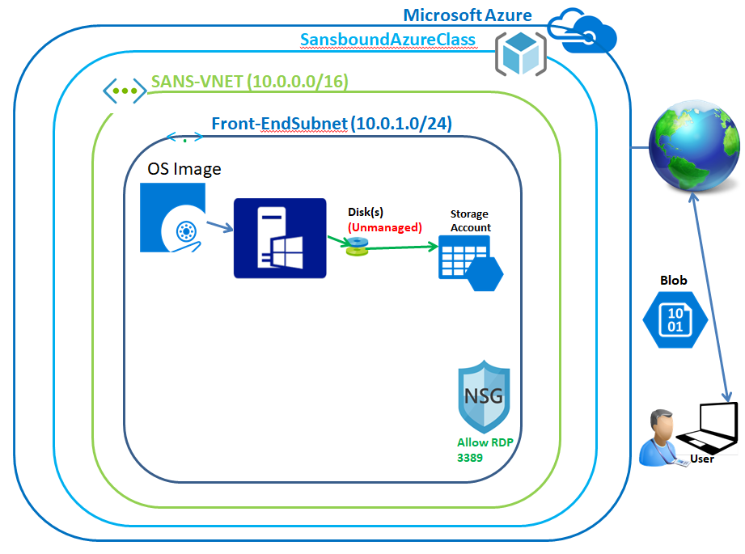

**Back-End of Storage**

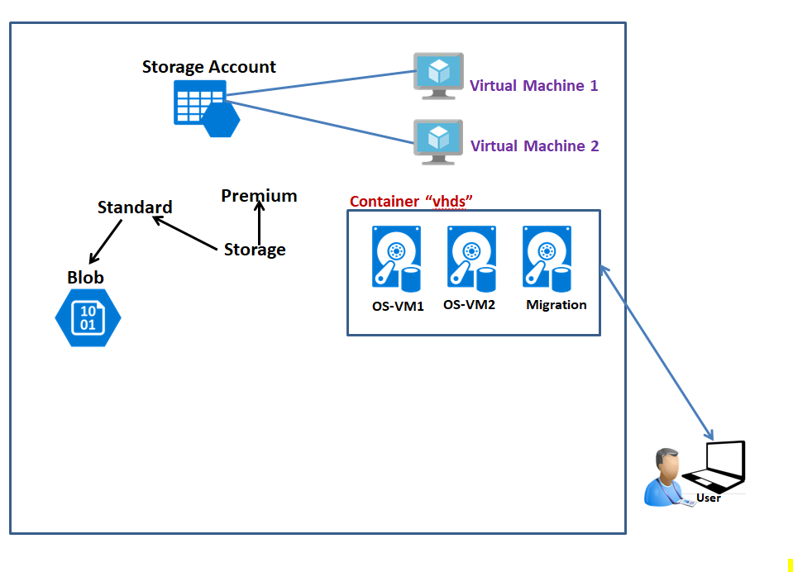

In Azure portal, click **“Resource groups”** in left side panel.

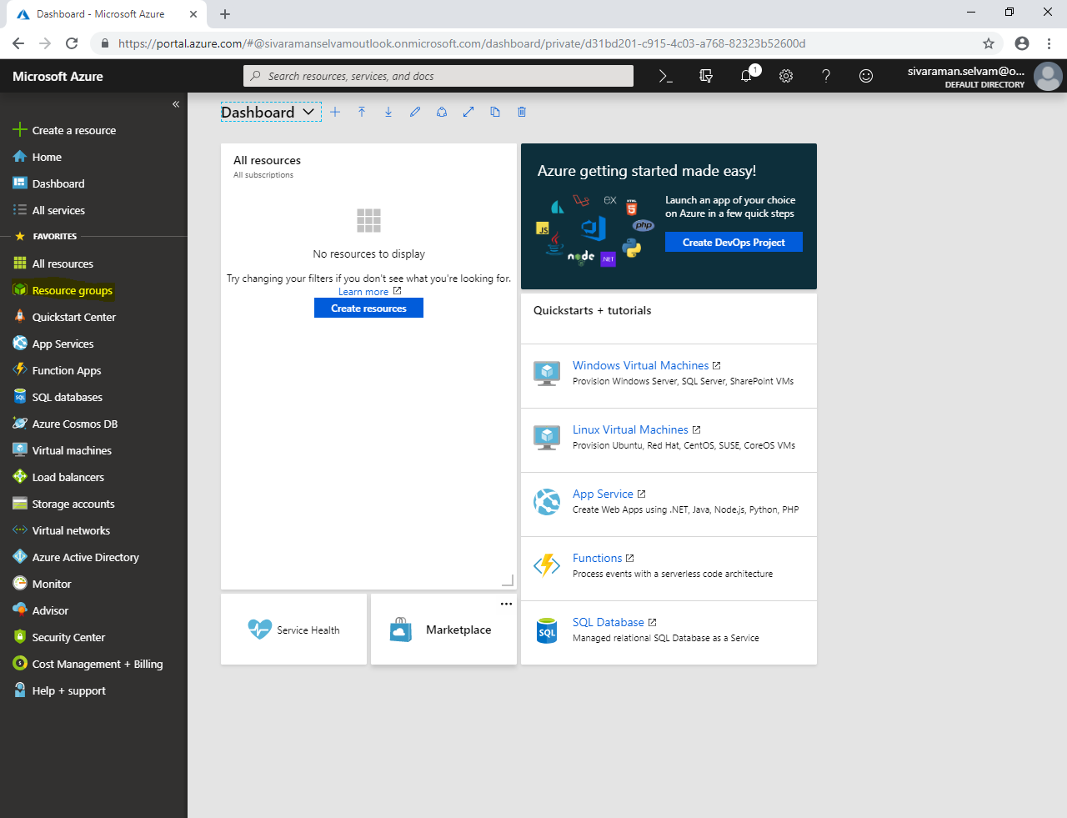

Click **“Add”.**

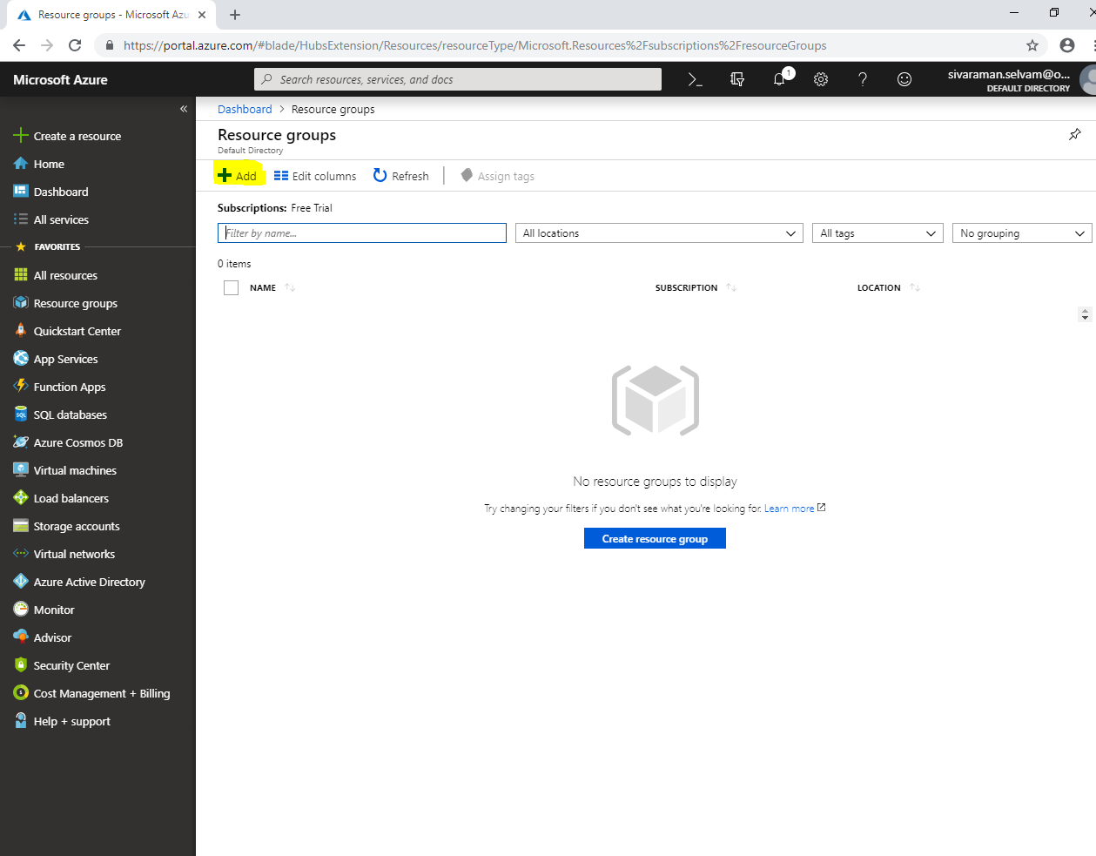

While create **“Resource group”,** type **“Resource group name”** as **“SansboundAzureClass”**.

Select **“Subscription”** as **“Free Trial”**.

Select **“Resource group location”** as **“South India”**.

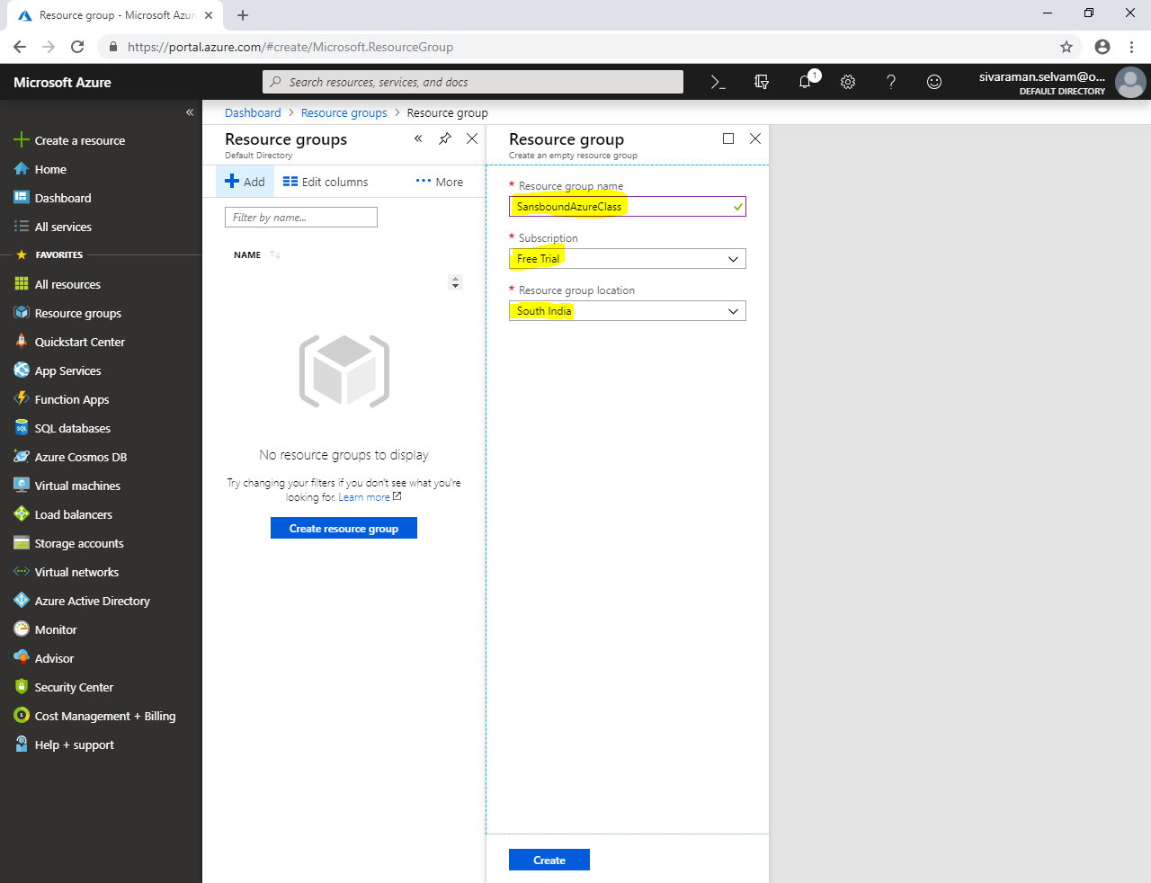

Click **“Create”**.

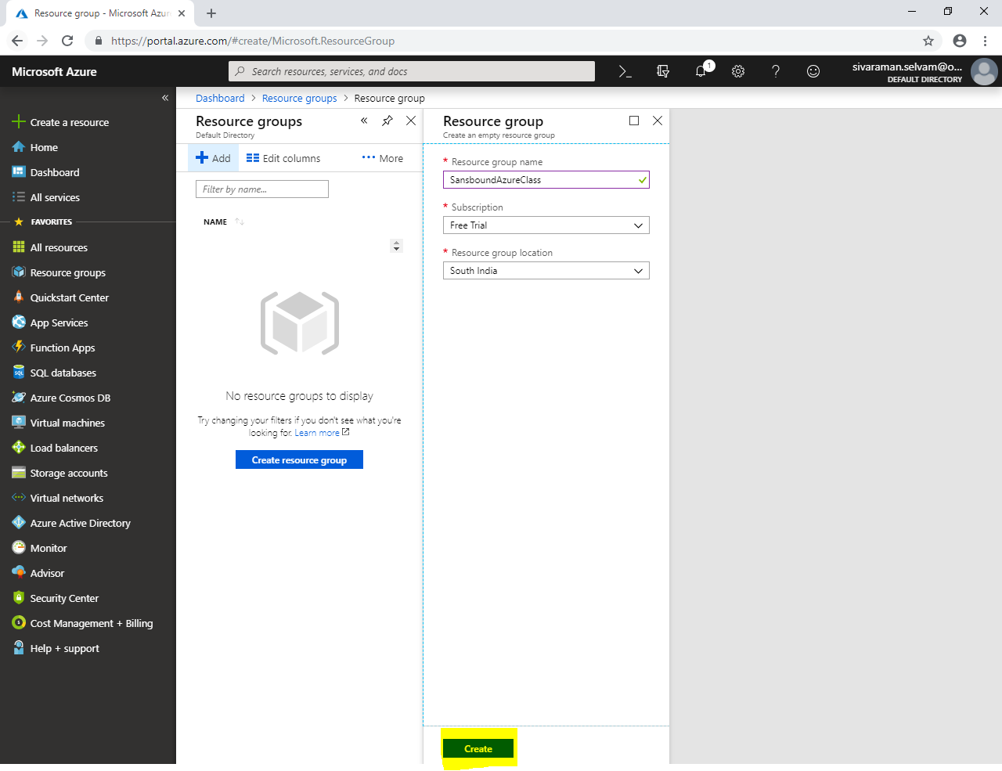

Click **“Virtual networks”** in left side panel.

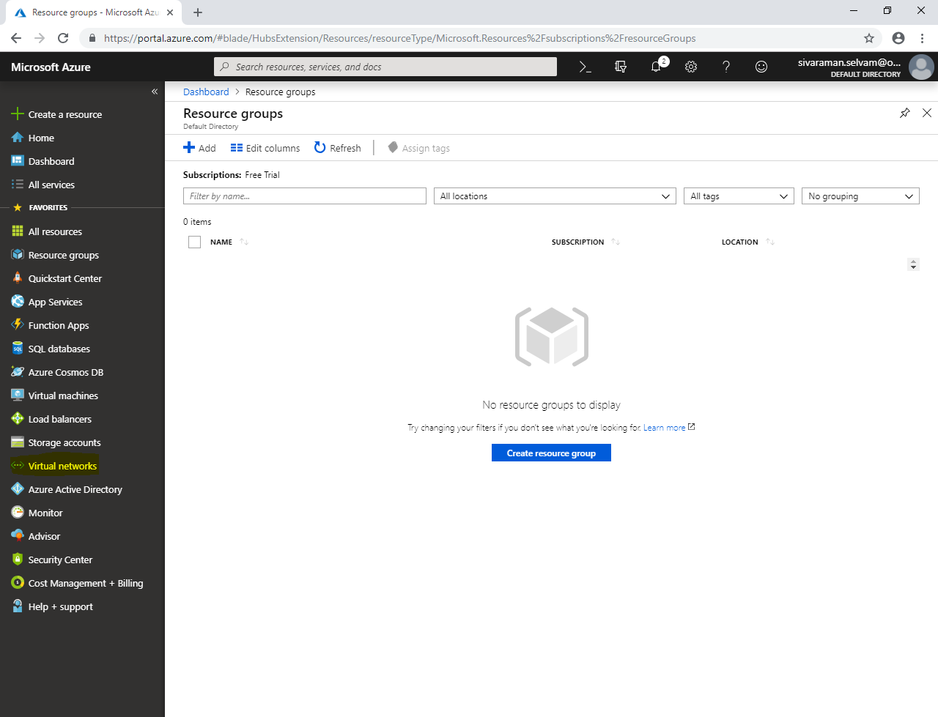

In **“Virtual networks”**, click **“Add”**.

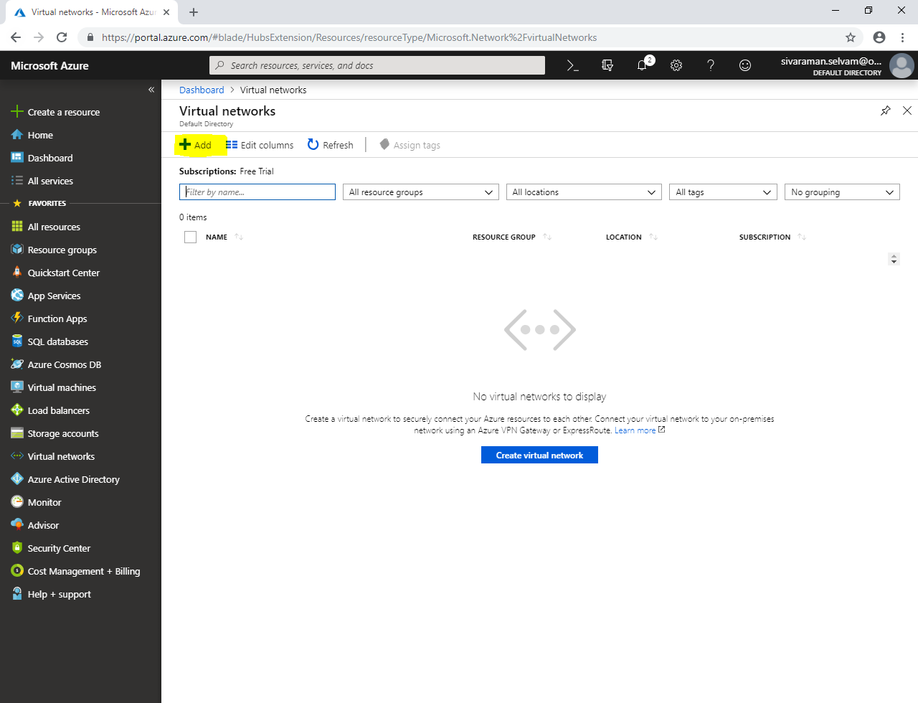

Type **“Virtual network name”** as **“SANS-VNET”**.

Type **“Address range”** as **10.0.0.0/16**

Select **“Subscription”** as **“Free Trial”**.

Select **“Resource Group”** as **“SansboundAzureClass”**.

Select **“Location”** as **“South India”**.

In **“Subnet”** type **“Subnet name”** as **“Front-EndSubnet”**

Type **“Address range”** as **10.0.1.0/24.**

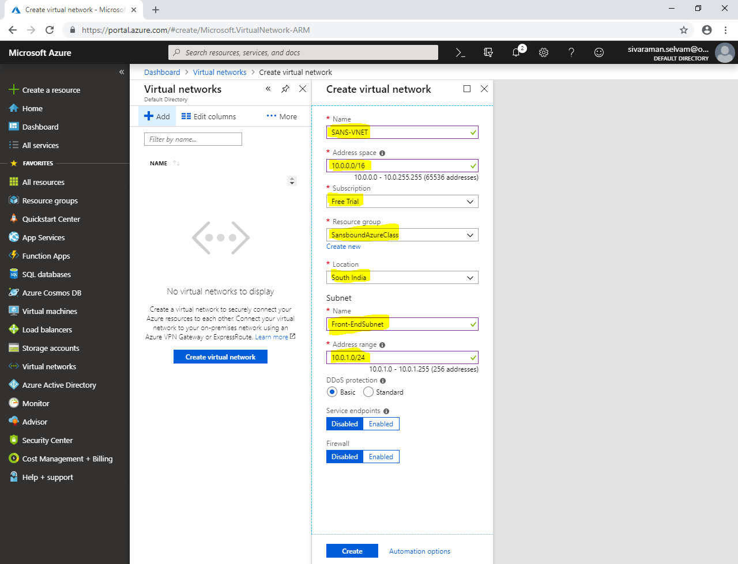

Click **“Create”**.

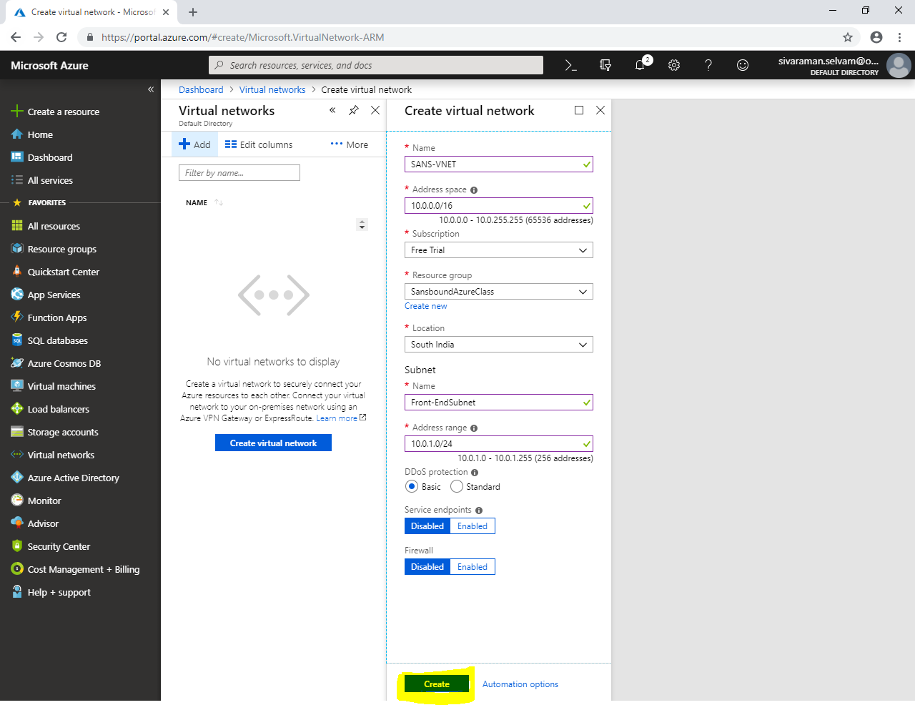

Click **“Virtual machines”**.

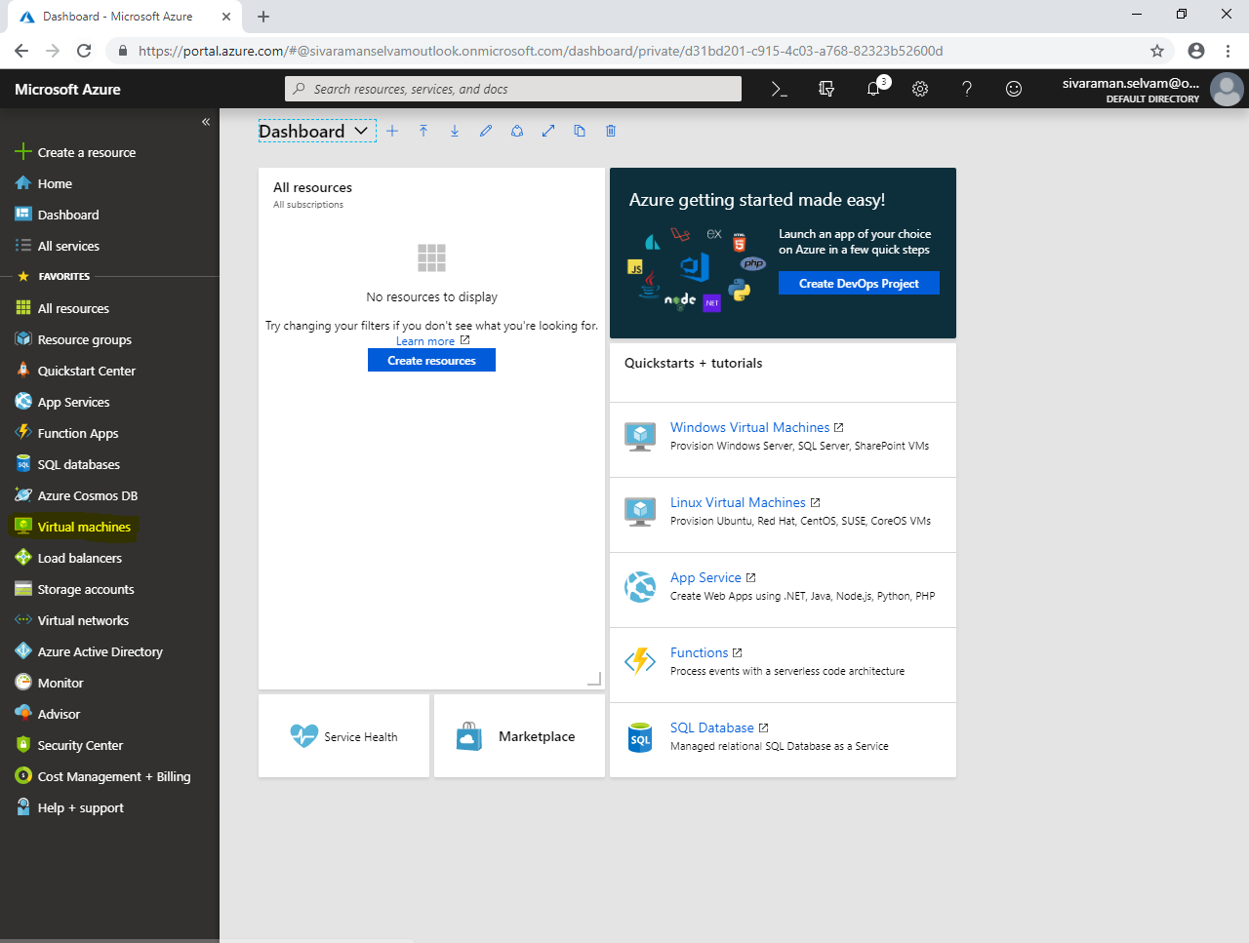

Click **“Add”**.

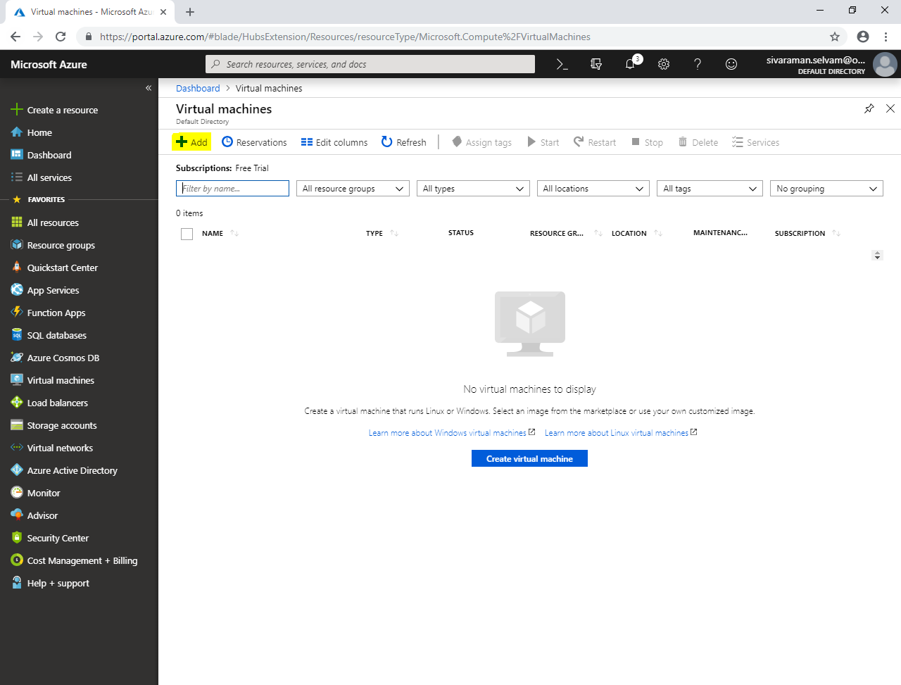

While create a virtual machine,

Type **“Virtual machine”** name as **“WindowsVM-Azure”**.

Select **“Region”** as **“South India”**.

Select **“Image”** as **“Windows Server 2008 R2”**.

Change **“VM Size”** as **“Standard B1s”**.

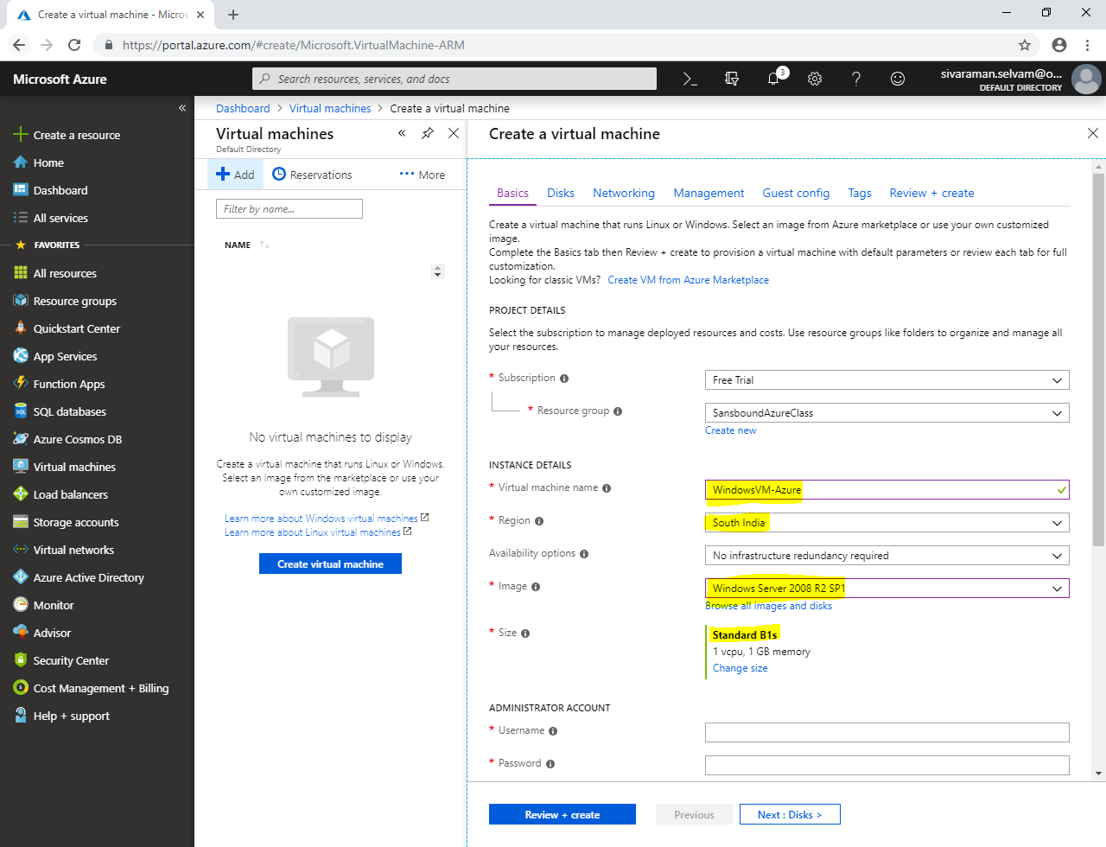

In **“Administrator Account”**

In **“Username”** type **“sansbound”**, and type password as per your wish.

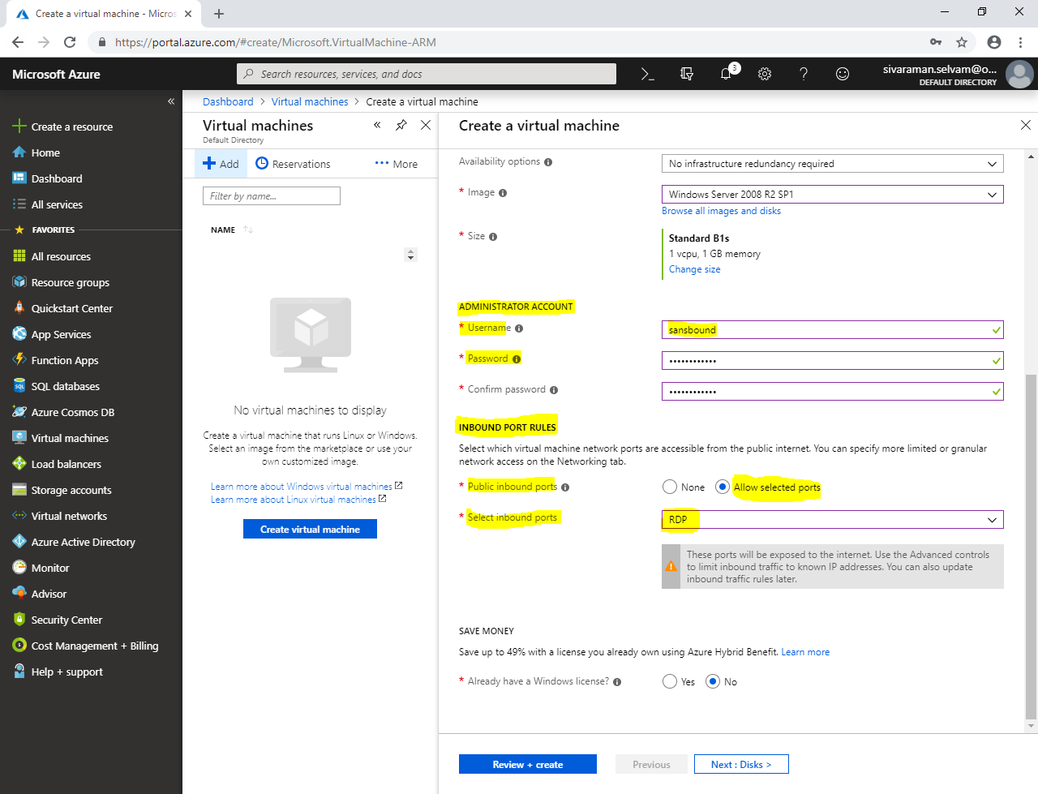

In **“Save Money”**.

Click **“Yes”** for Already have a Windows license.

Need to check **“Confirmation”** box.

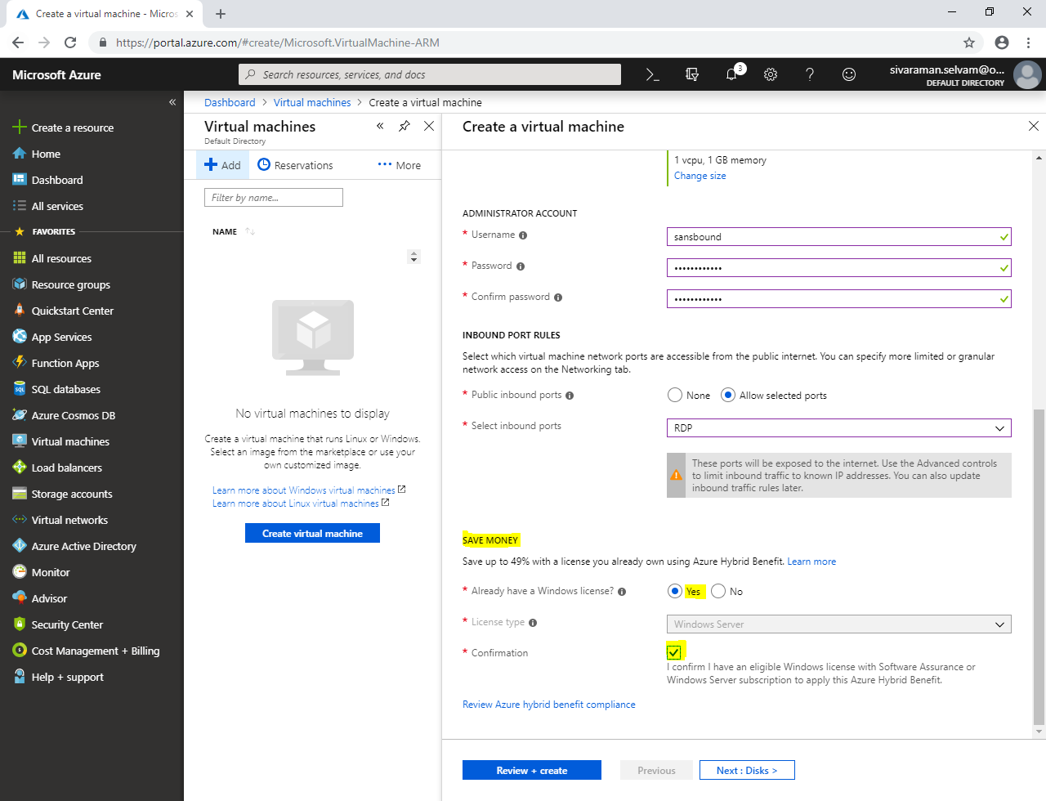

Click **“Next : Disks >”**.

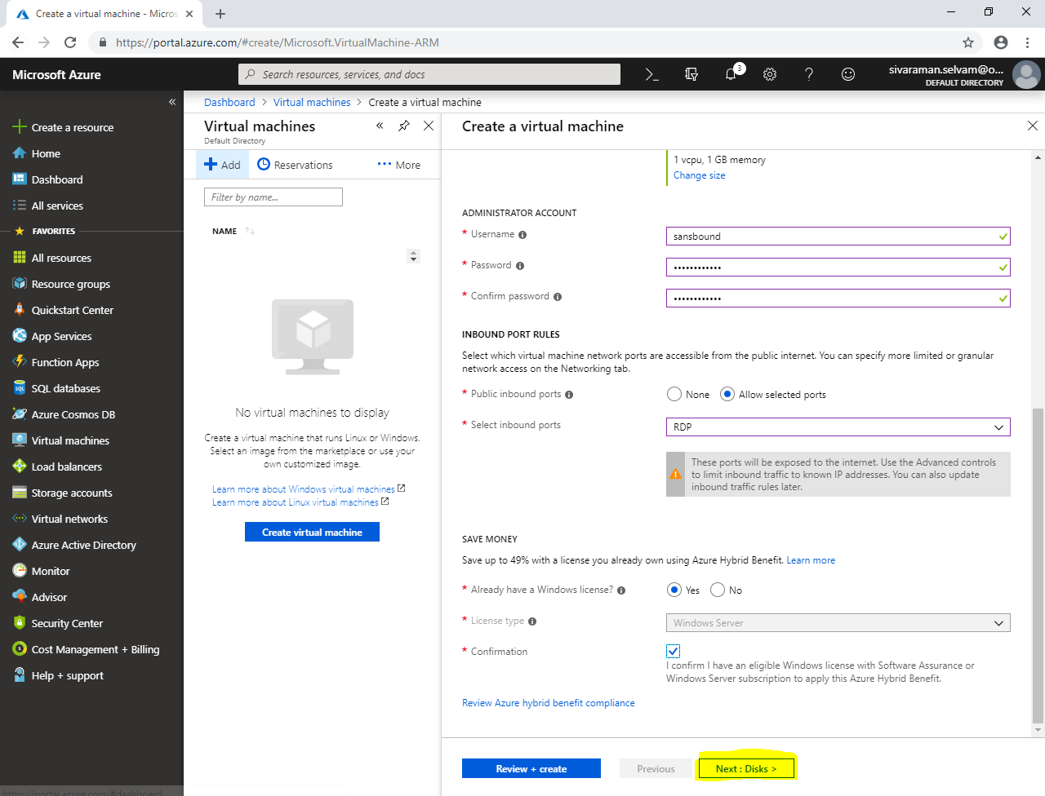

In **“Disks”**.

Select **“OS disk type”** as **“Standard HDD”**.

Expand **“Advanced”**.

Set Use managed disks as **“No”**.

Leave Storage account as default.

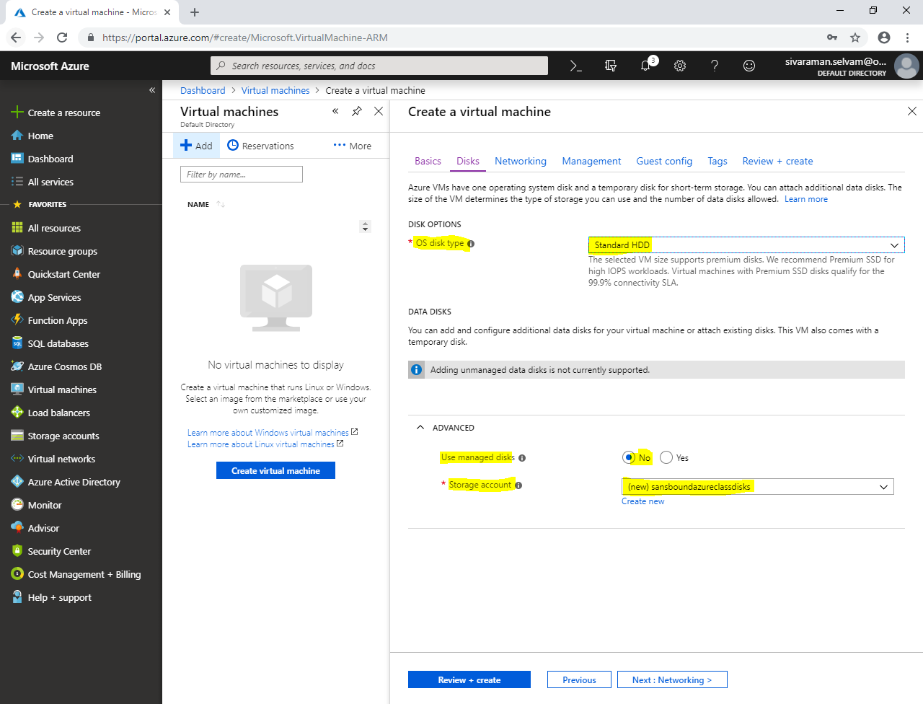

Click **“Next : Networking”**.

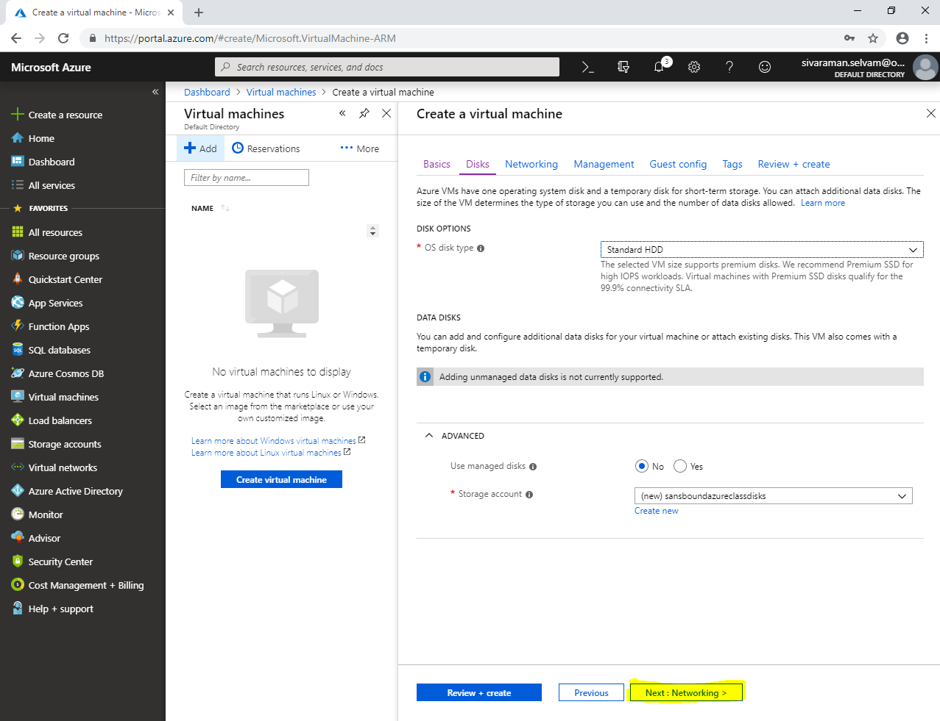

In **“Networking”**.

Ensure the highlighted options as below.

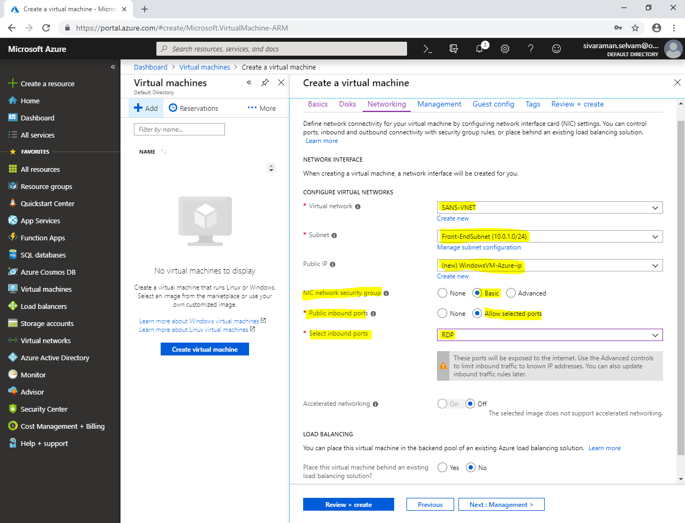

In **“Management”**.

Click **“Next : Guest config>”**.

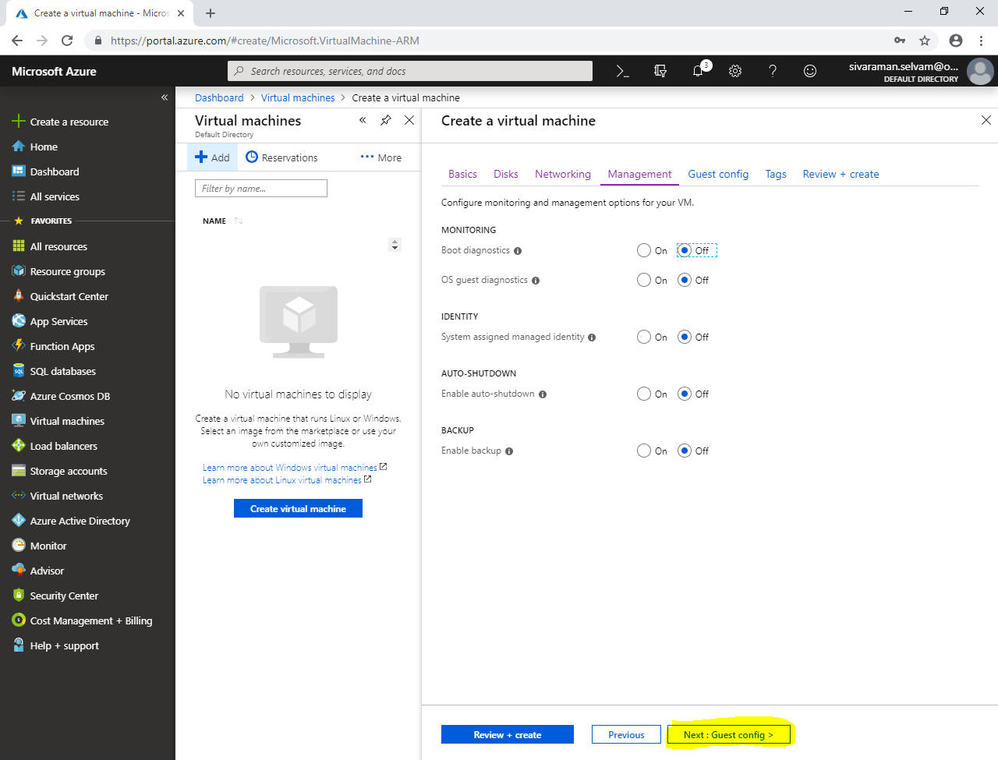

In **“Guest config”**.

Click **“Next : Tags >”**.

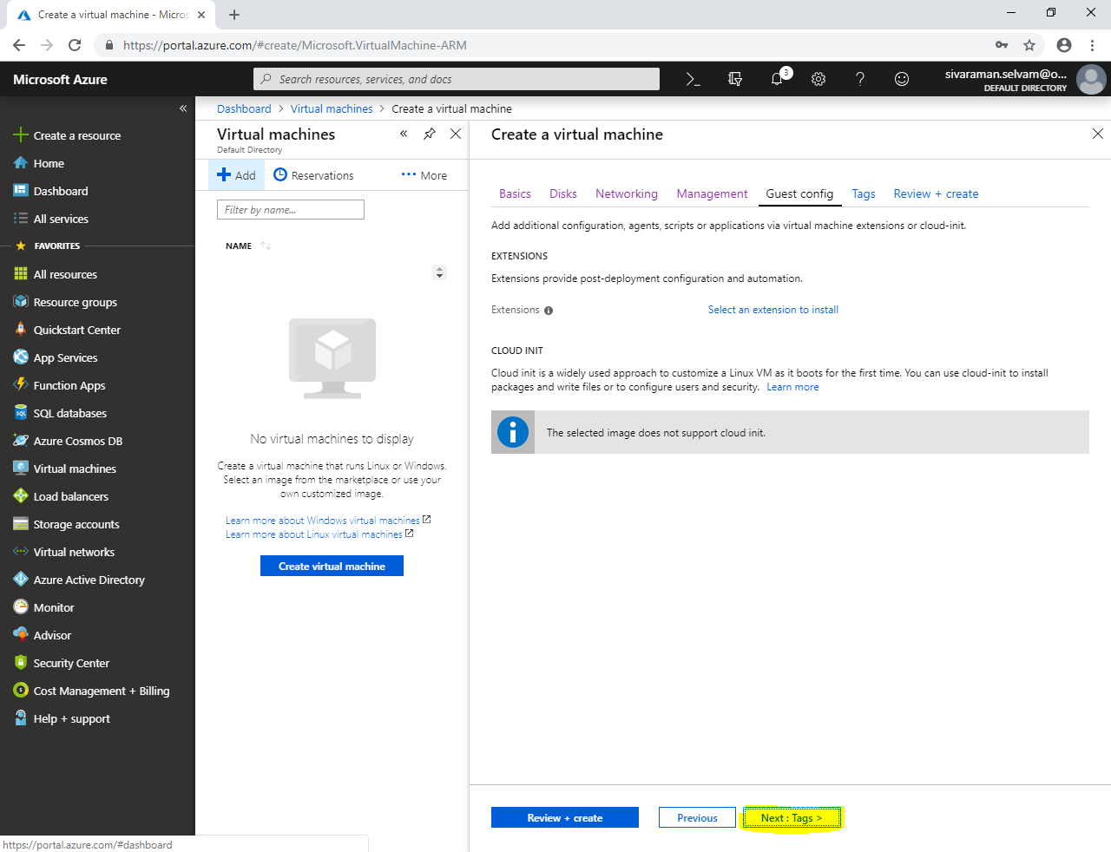

In **“Tags”**.

Click **“Next : Review + create”**.

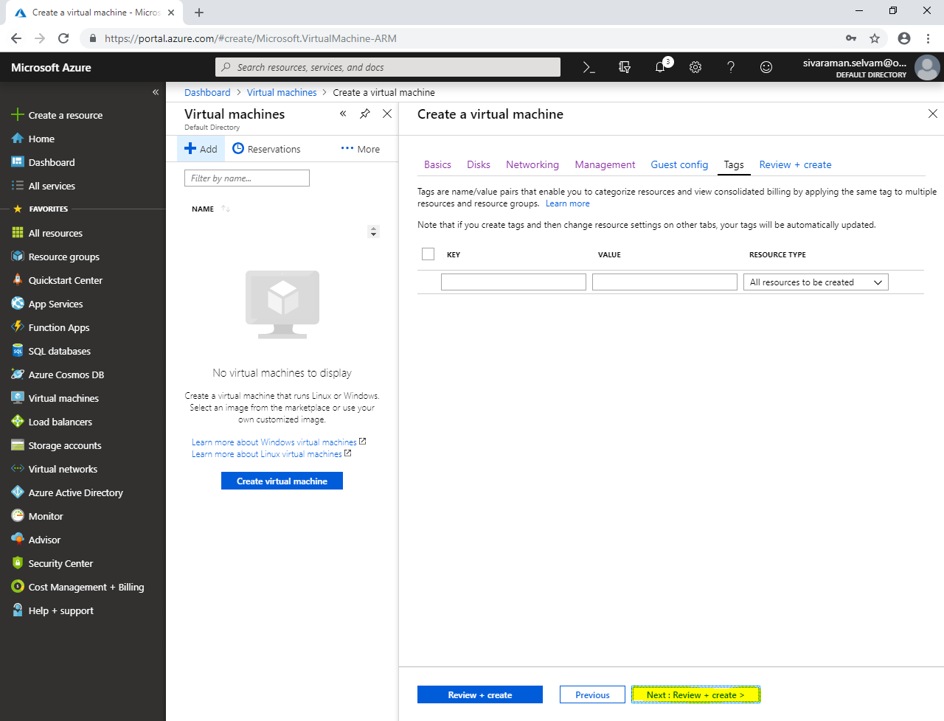

Click **“Create”**.

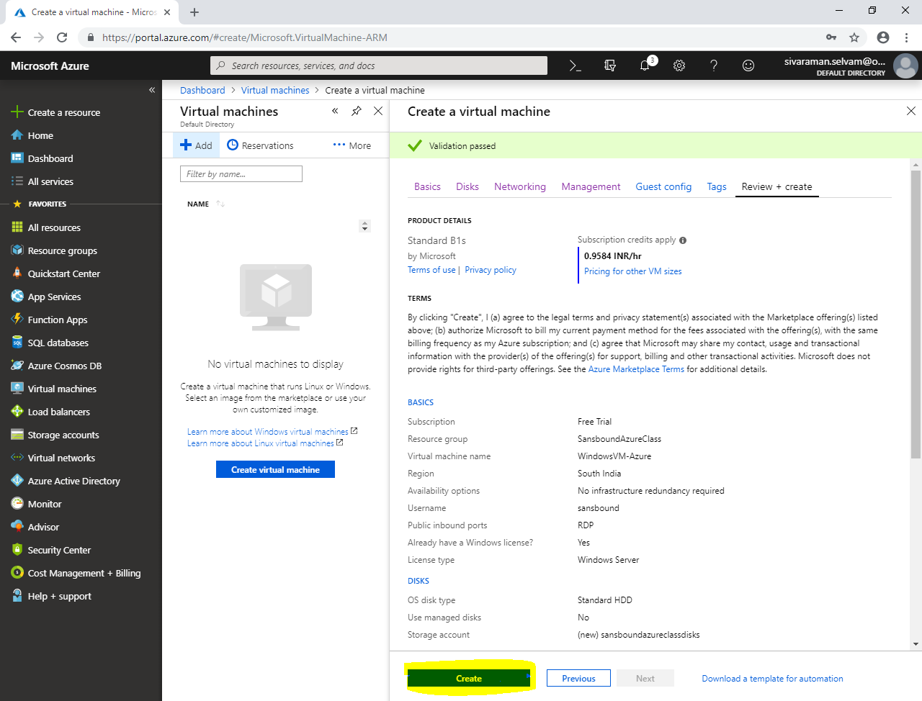

In **“All resources”**.

Click **“sansboundazureclassdisks”**.

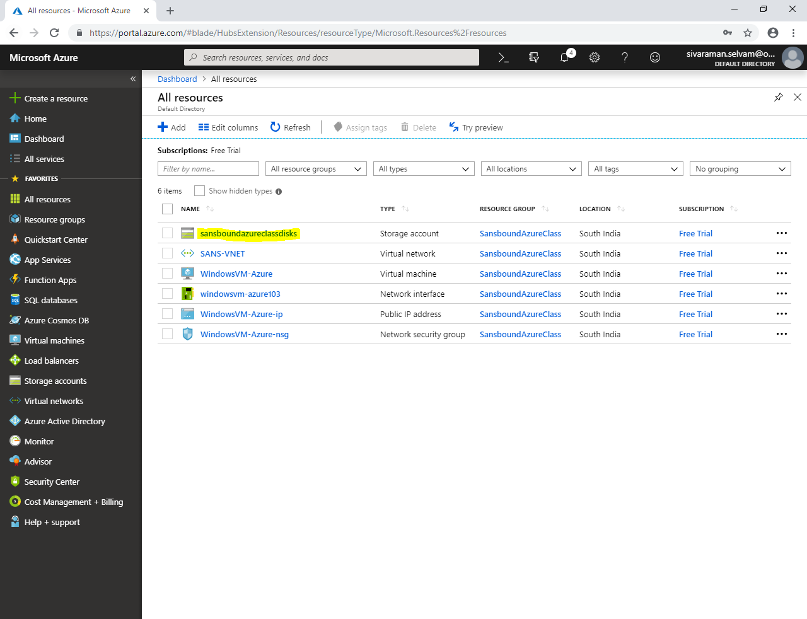

Click **“Blobs”**.

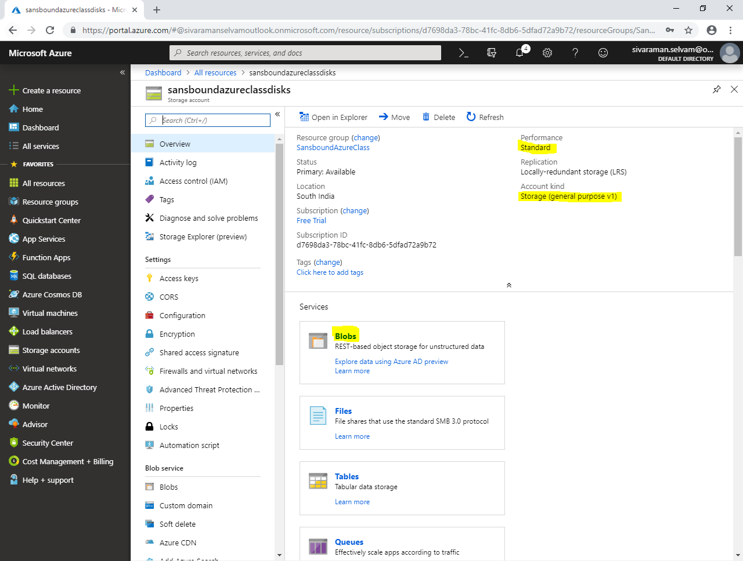

Click “**vhds”**.

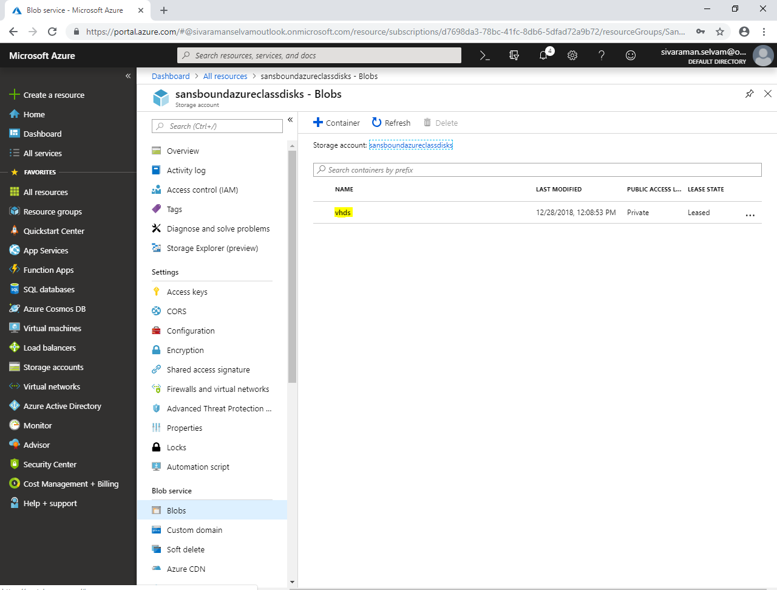

In **“vhds”**

You are able to see **“WindowsVM-Azure*.vhd”** which contains operating system.

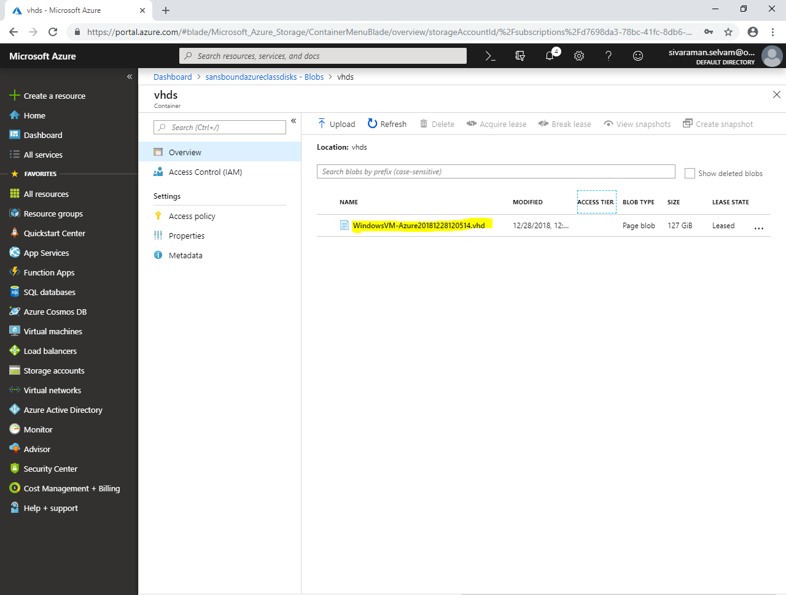

Now I have required to create one *.vhd file in my local machine.

In your local machine, type **“diskmgmt.msc”** in **“Run”** box and press **“Enter”**.

In **“Disk management”**, **Action 🡪 click “Create VHD”.**

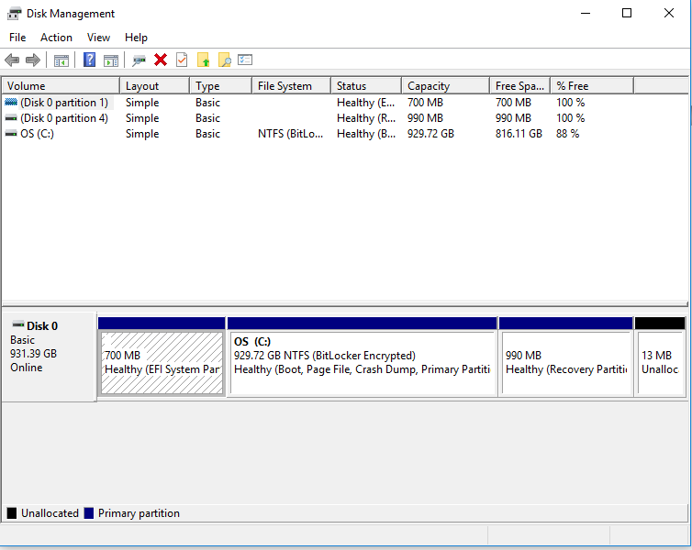

In **“Create and Attach Virtual Hard Disk”**.

Specify the **“Virtual hard disk size”** as **“30 MB”**.

Ensure hard disk format as **“VHD”**.

**Note: Because, as of now Azure will support only for .vhd file.**

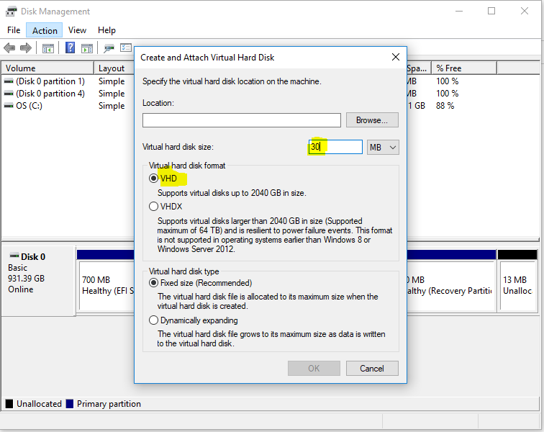

Click **“Browse”** to locate store the vhd file.

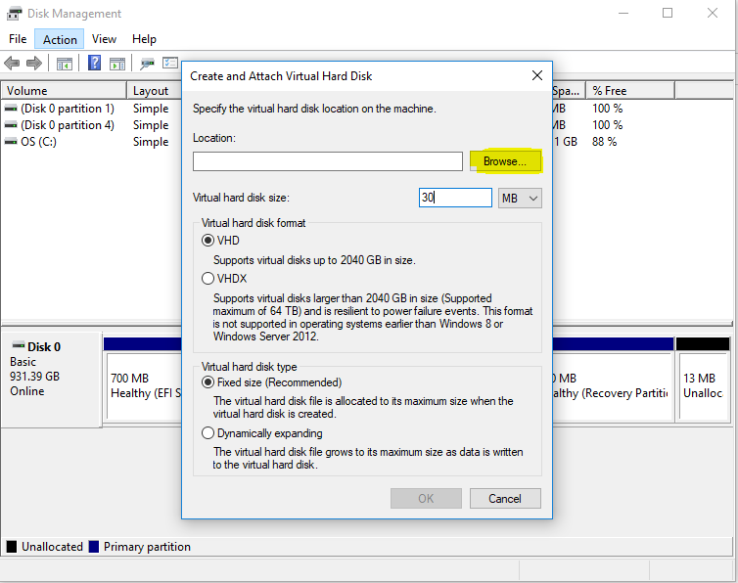

Type file name as **“Migration”** as file name and click **“Save”**.

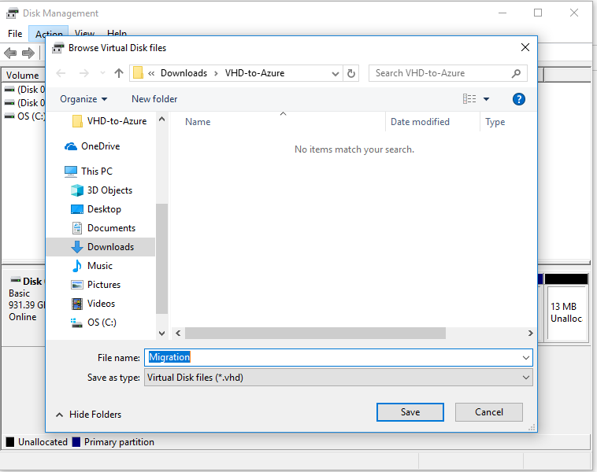

Click **“Ok”**.

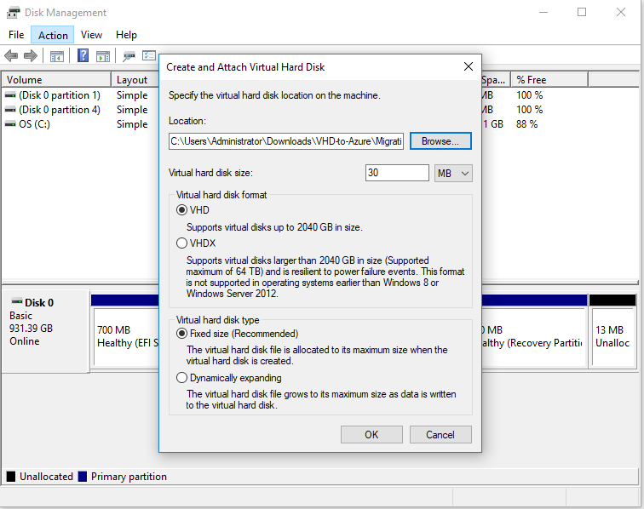

In **“Disk 1”** right click **“Initialize Disk”**.

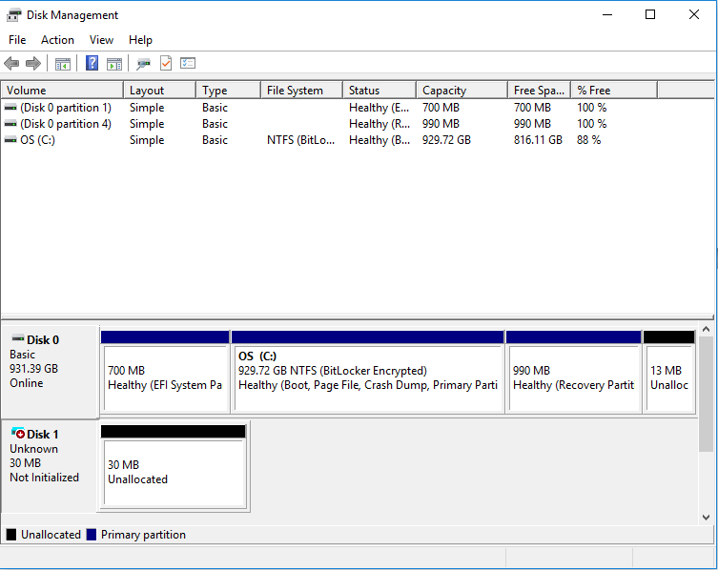

While **“Initialize Disk”**, ensure that **“MBR”** is selected.

Click **“Ok”.**

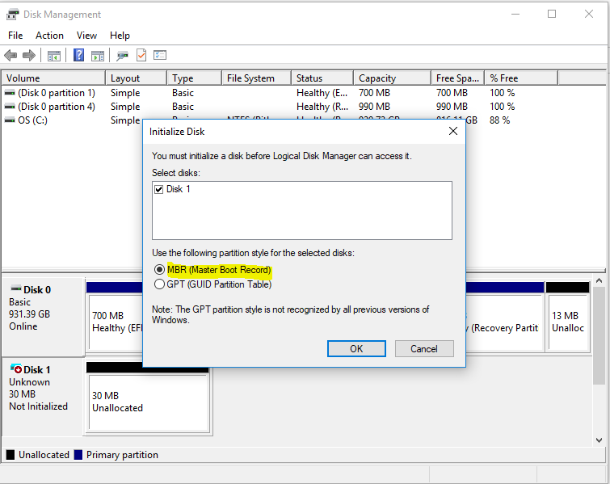

Select **“unallocated”** partition and right click it.

Click **“New Simple Volume”**.

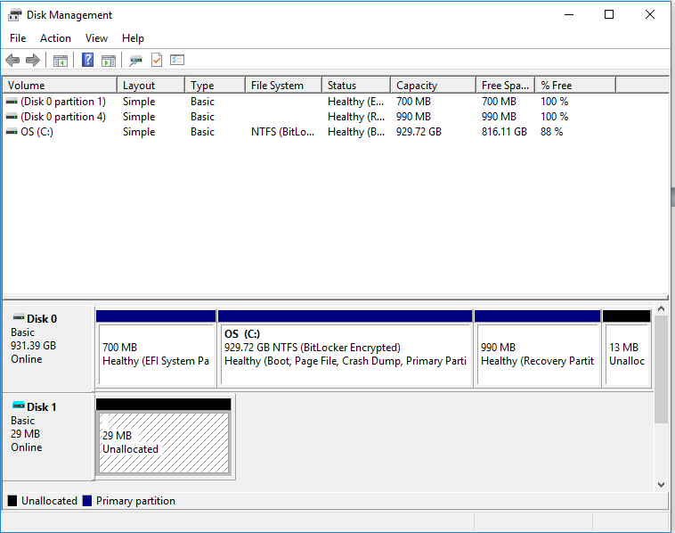

Click **“Next”**.

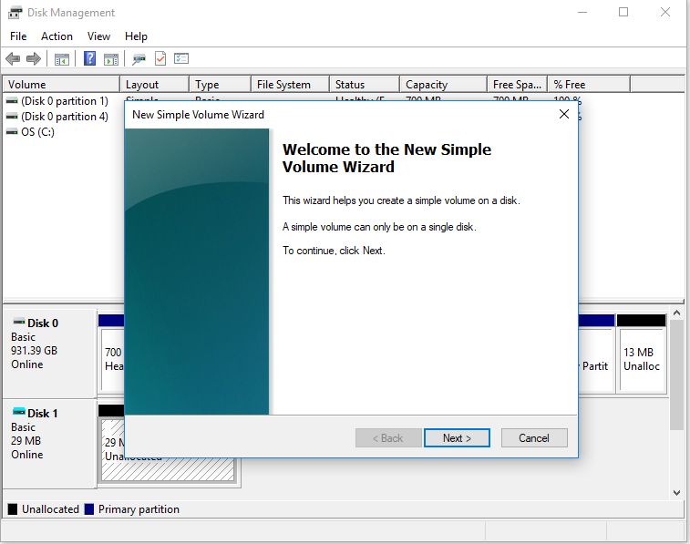

Click **“Next”**.

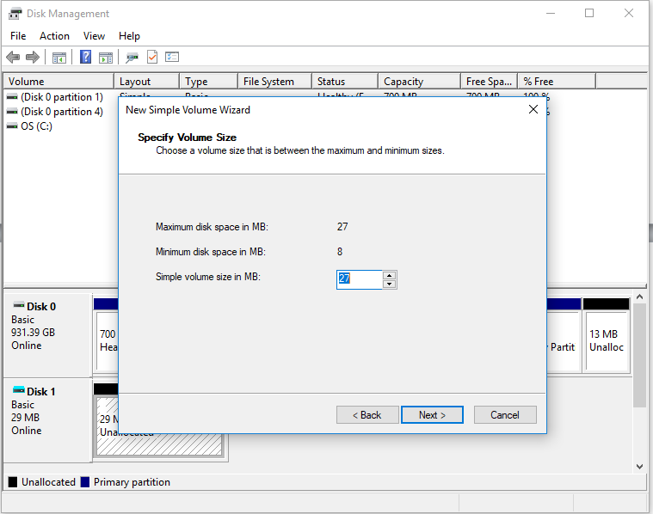

Click **“Next”**.

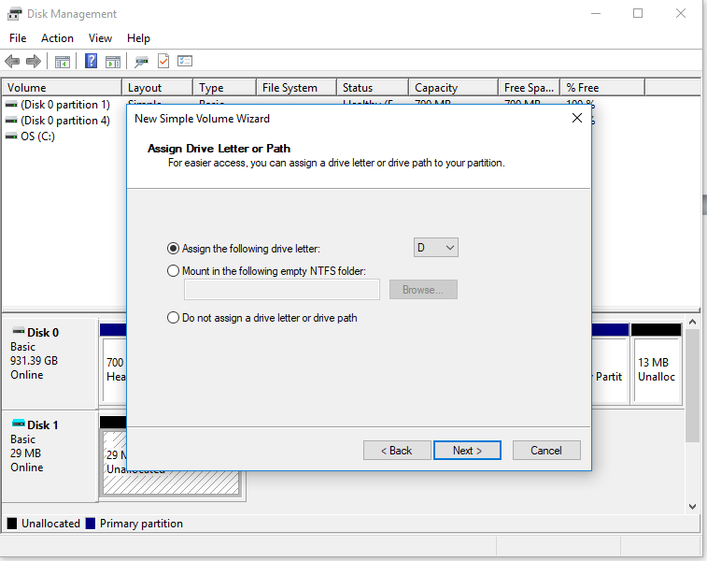

In **“Volume label”** type **“Data-To-Azure”**.

Click **“Next”**.

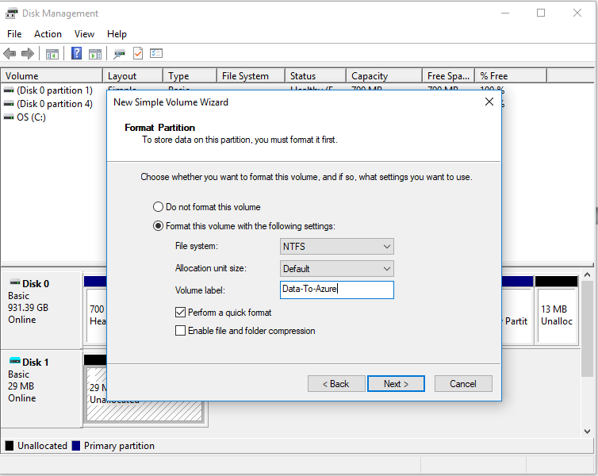

Click **“Finish”**.

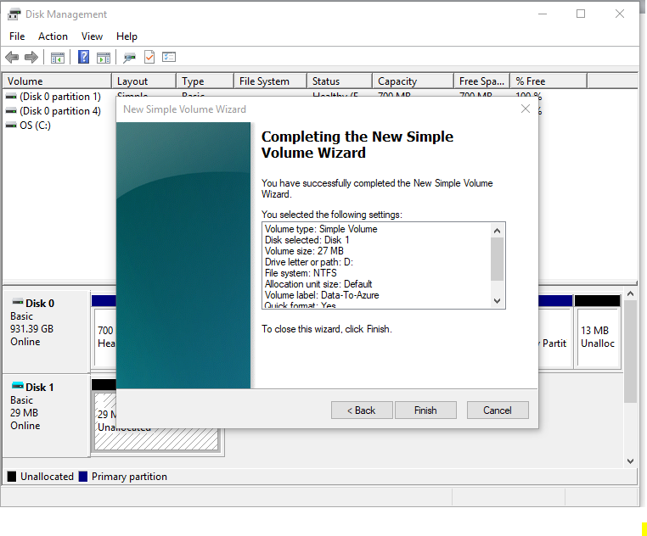

I have successfully mounted *.vhd file as volume.

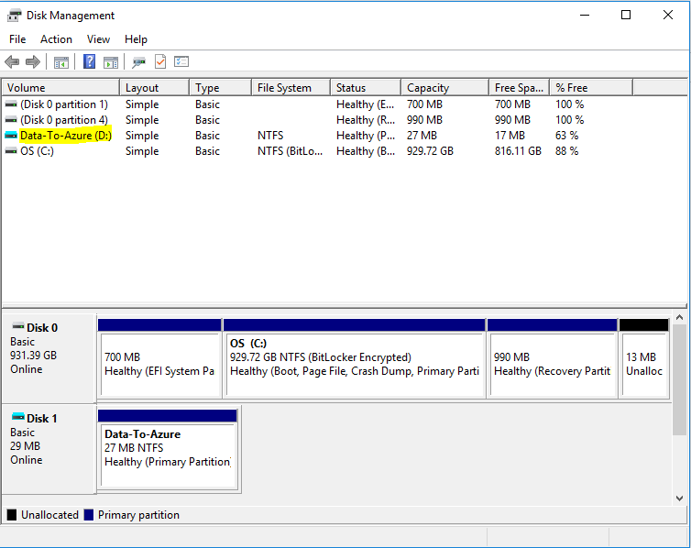

In **“Data-To-Azure”**.

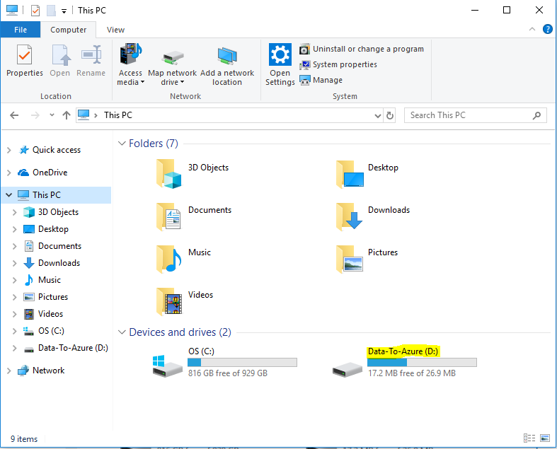

Create files / copy files which you have required to upload to Azure.

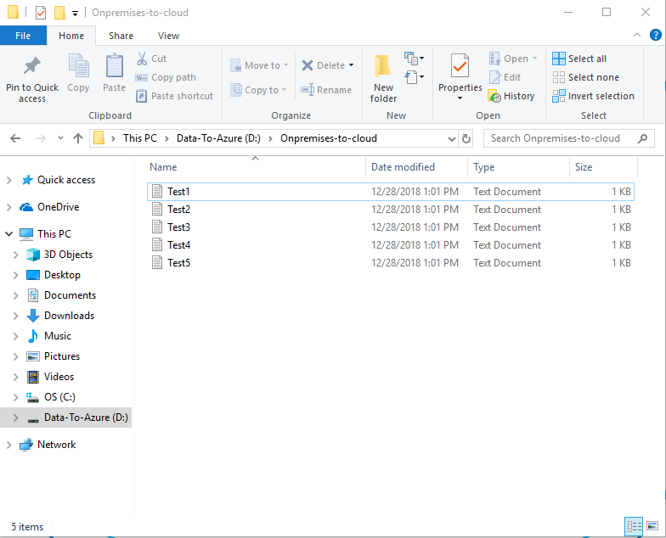

Now we have required to detach the VHD file from local machine.

In local machine, **“Disk management”**.

Click **“Disk 1”** and right click it, then click **“Detach VHD”**.

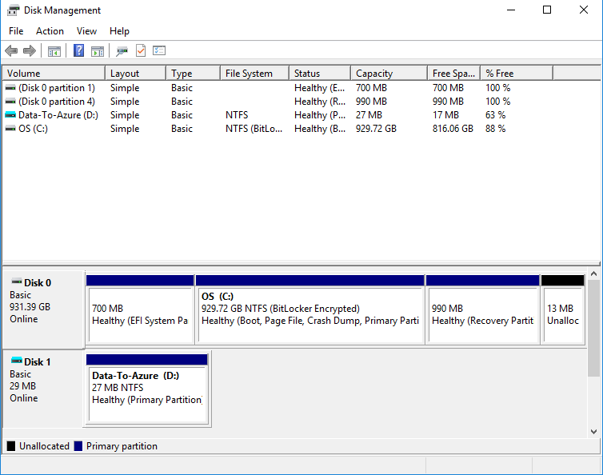

Click **“Ok”** to Detach Virtual Hard disk.

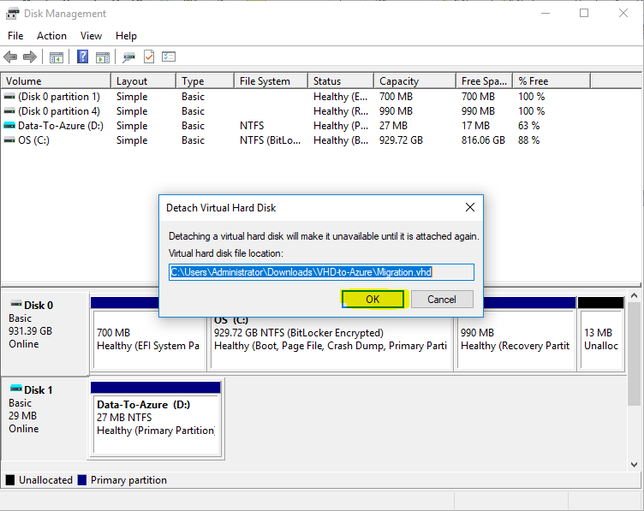

Ensure that vhd has been detached successfully.

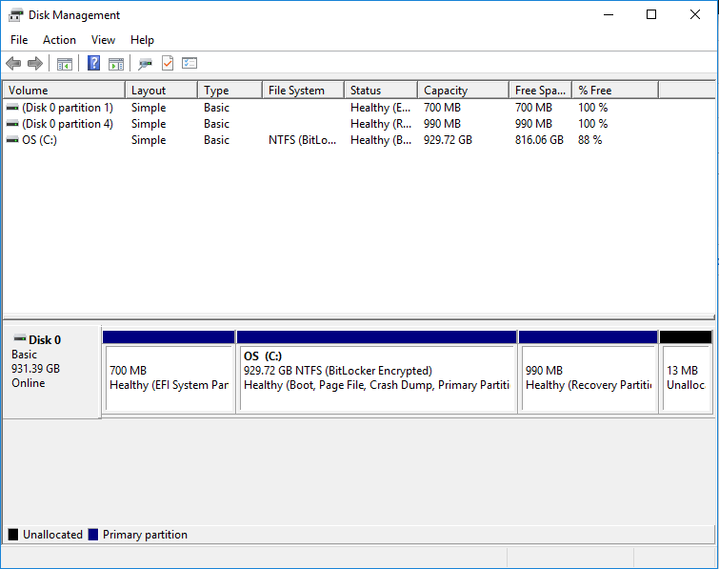

Go to the path where you have stored the “migration.vhd” file.

You are able to see the Migration.vhd file.

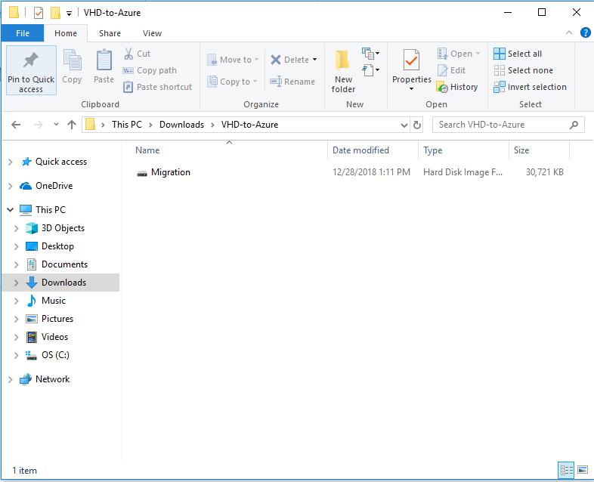

In Azure portal, click **“Storage accounts”**.

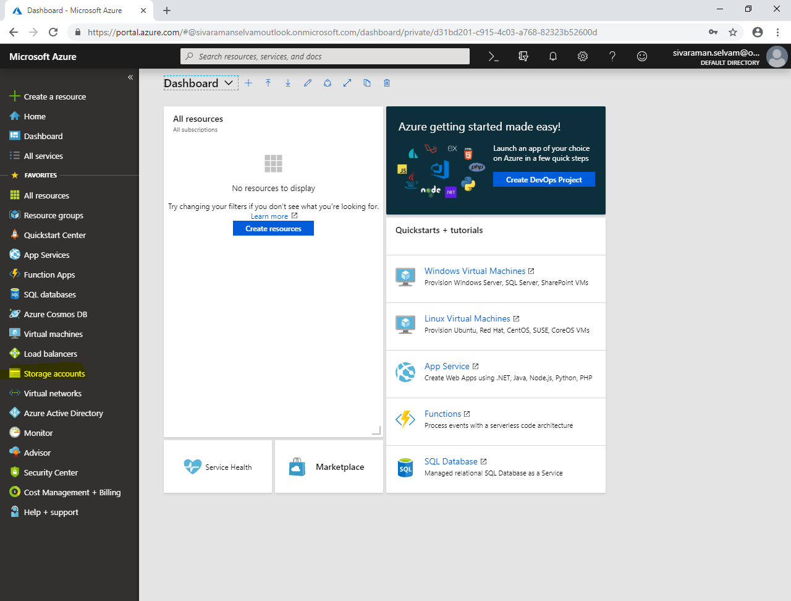

You are able to see the storage which you have created earlier.

Click on storage account named **“sansboundazureclassdisks”**.

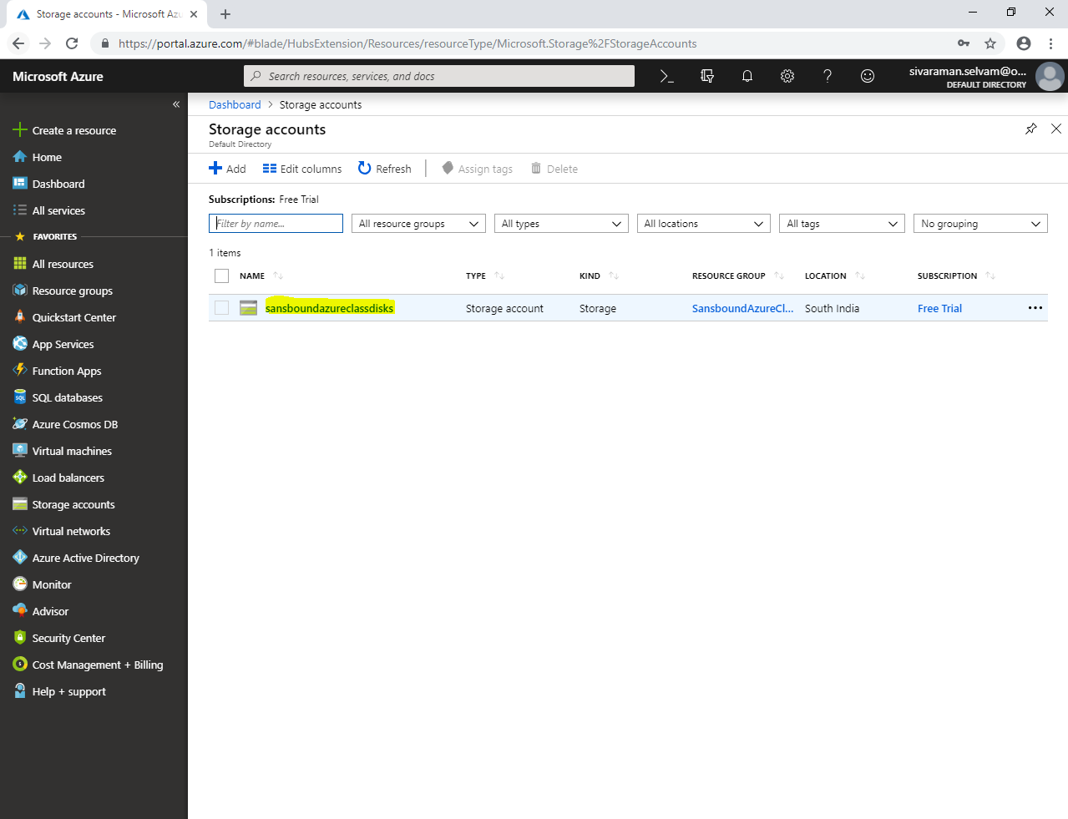

In **“sansboundazureclassdisks”**,

Click **“Blobs”**.

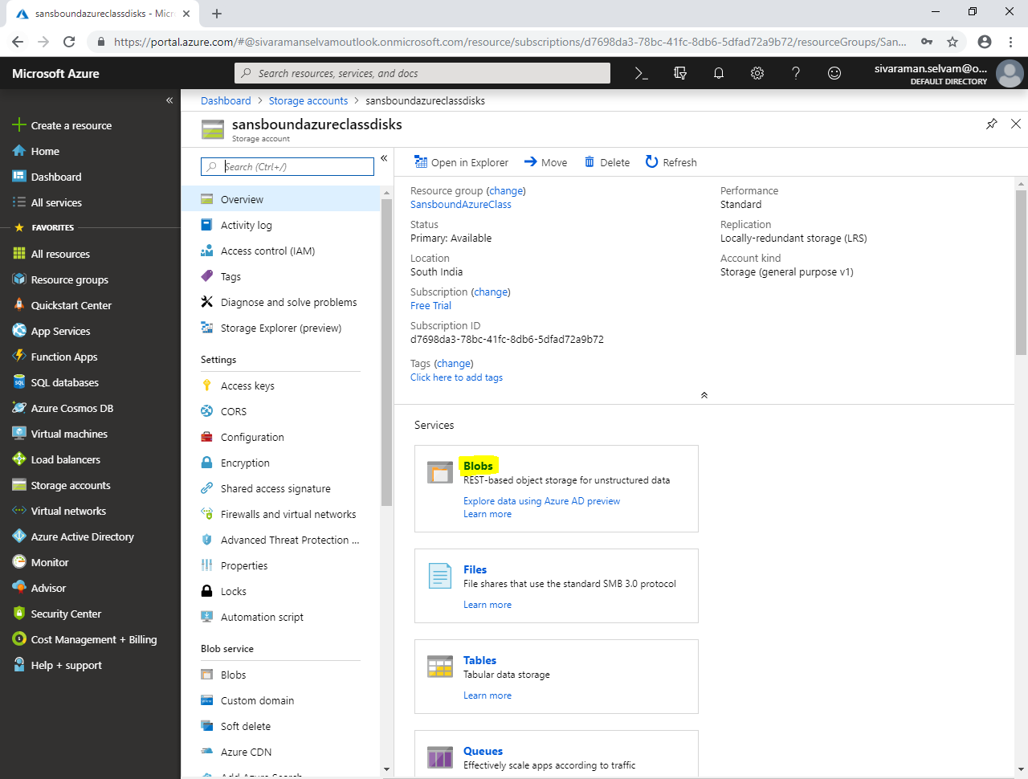

In **“Blobs”**, you are able to see the container named **“vhds”**.

Click **“vhds”**.

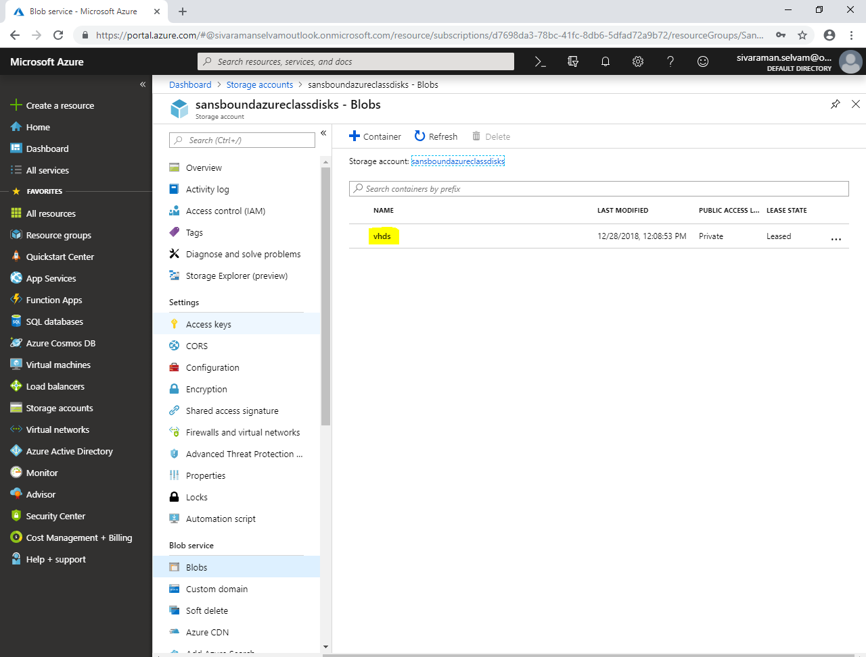

Click **“Upload”**.

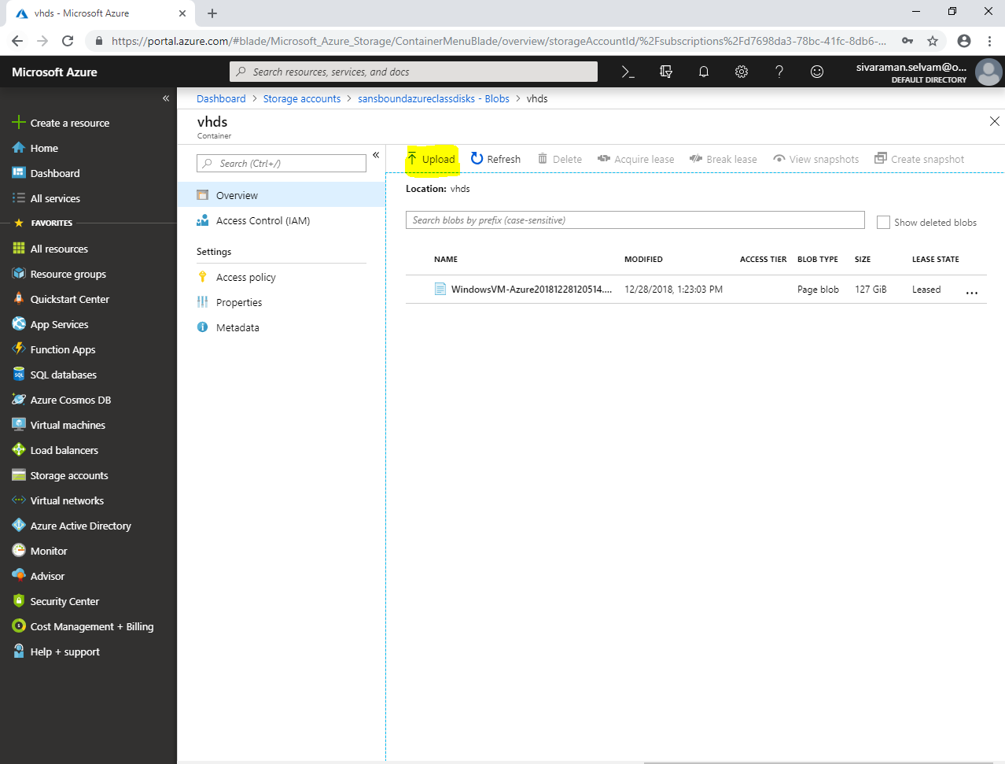

Click **“Files”** icon to browse the file.

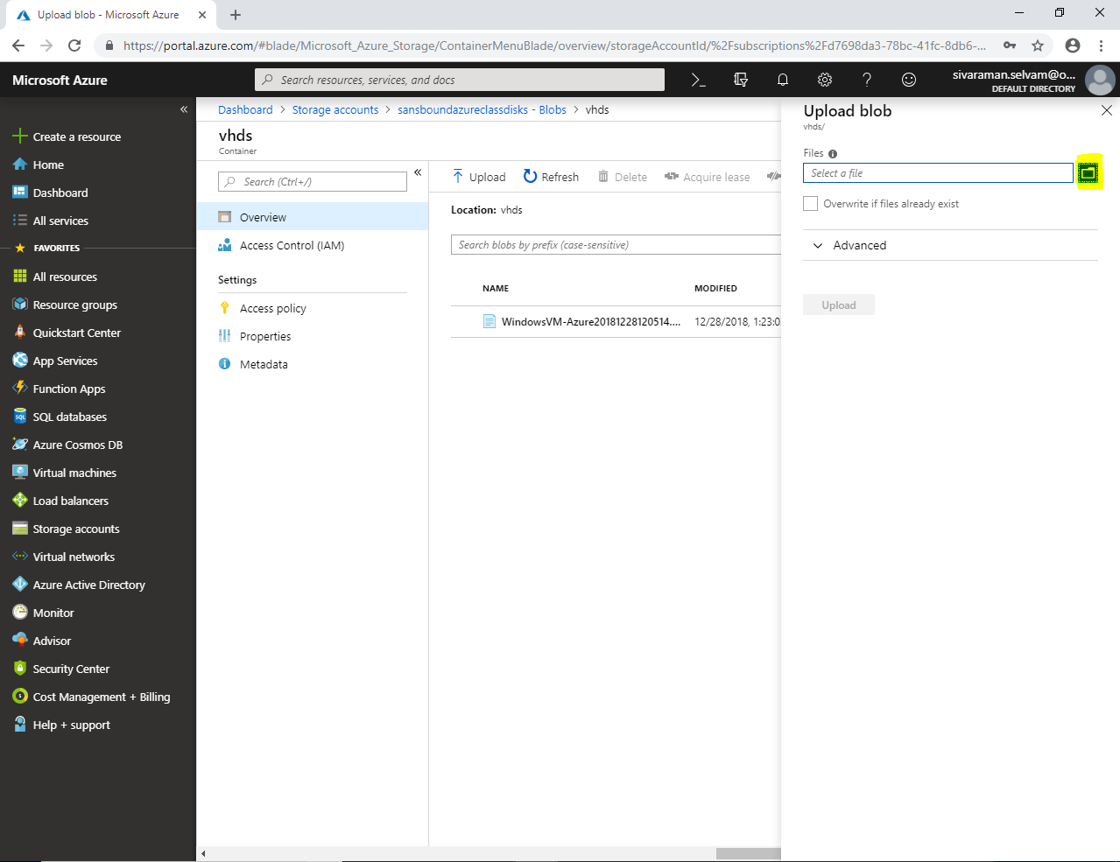

Locate the path of vhd file, and select **“Migration.vhd”** which you have created in your local machine.

Click **“Open”**.

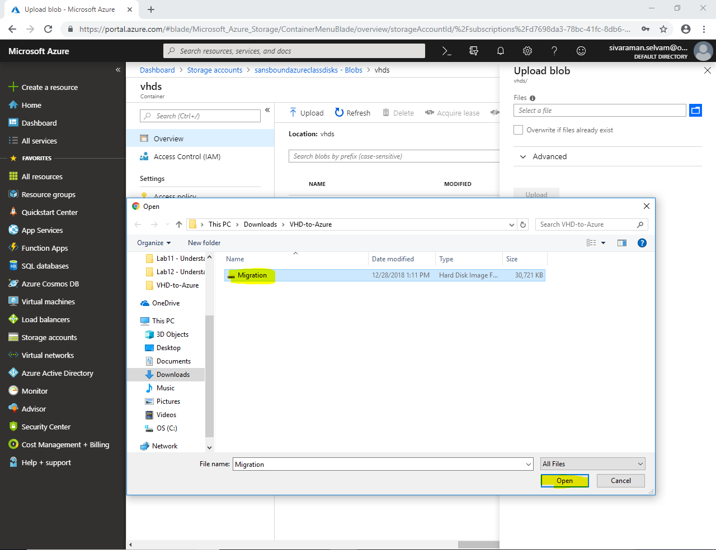

Ensure that selected Files as **“Migration.vhd”**.

Click **“Upload”**.

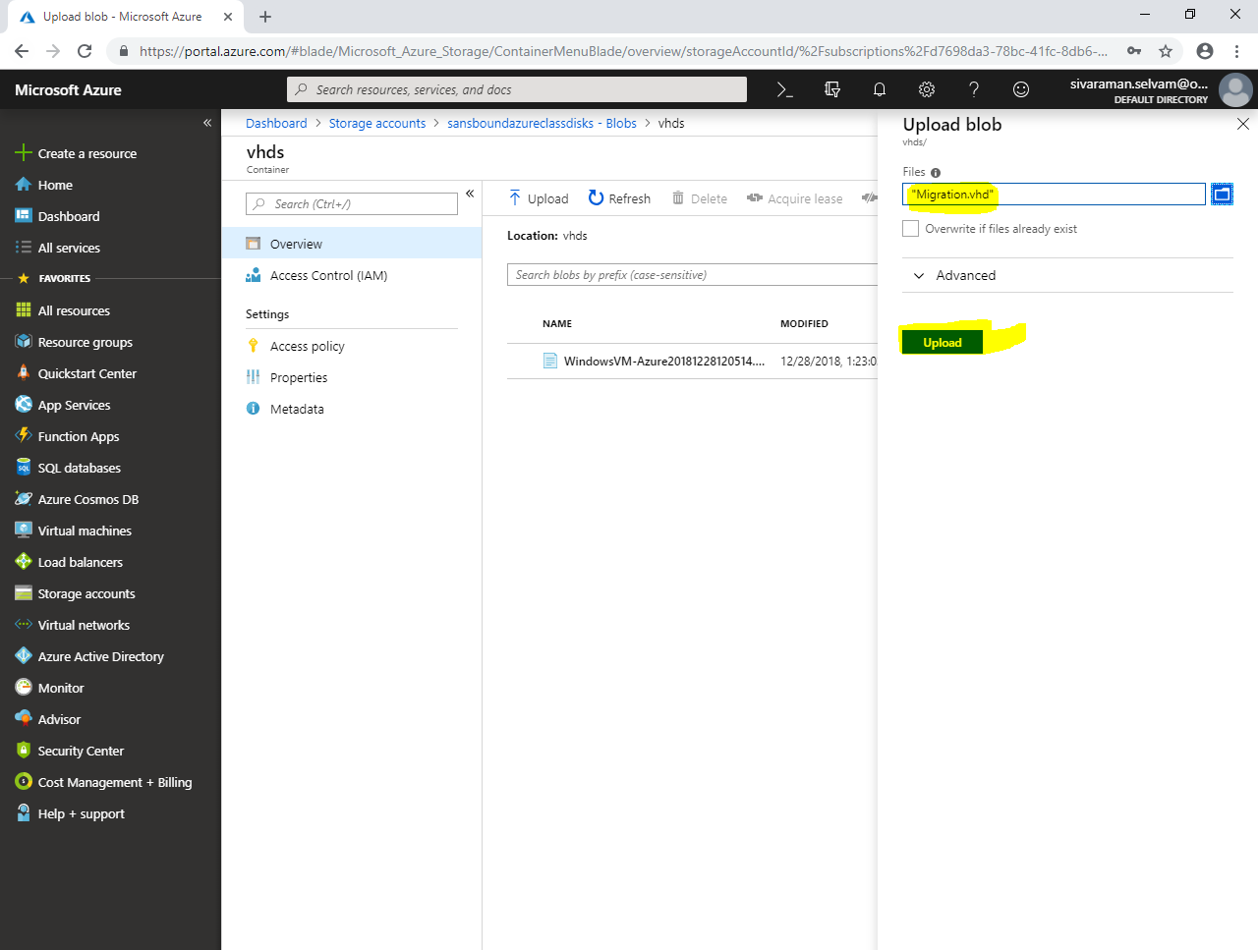

You have successfully uploaded the “Migration.vhd” file to Azure Blob storage.

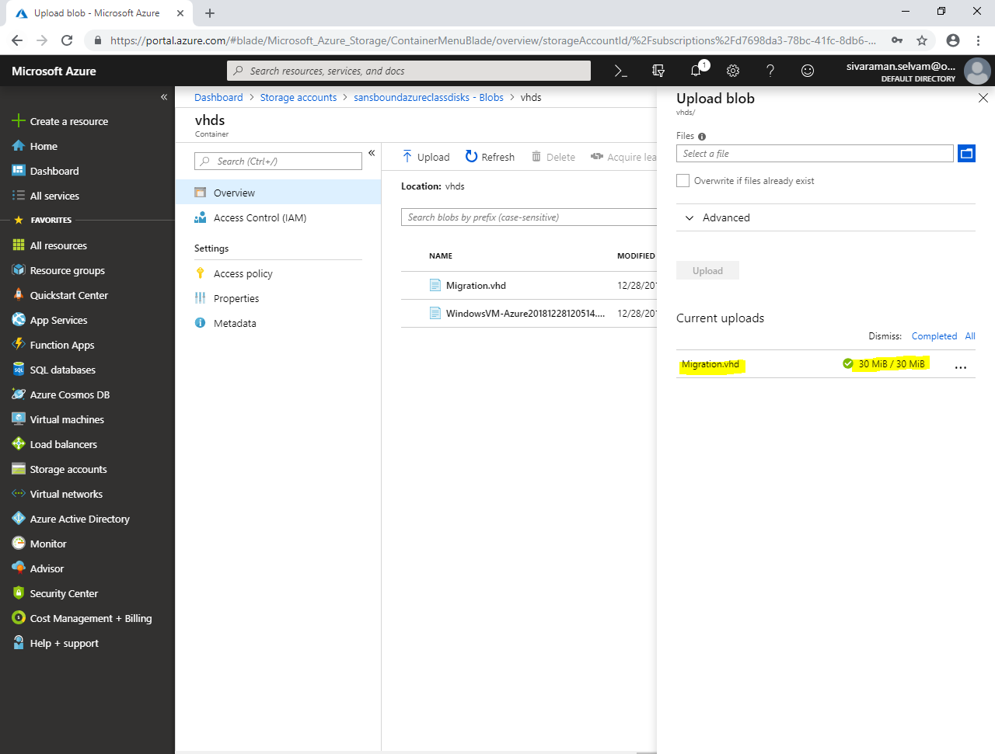

In **“Migration.vhd”** ensure the Size as **“30 MB”**.

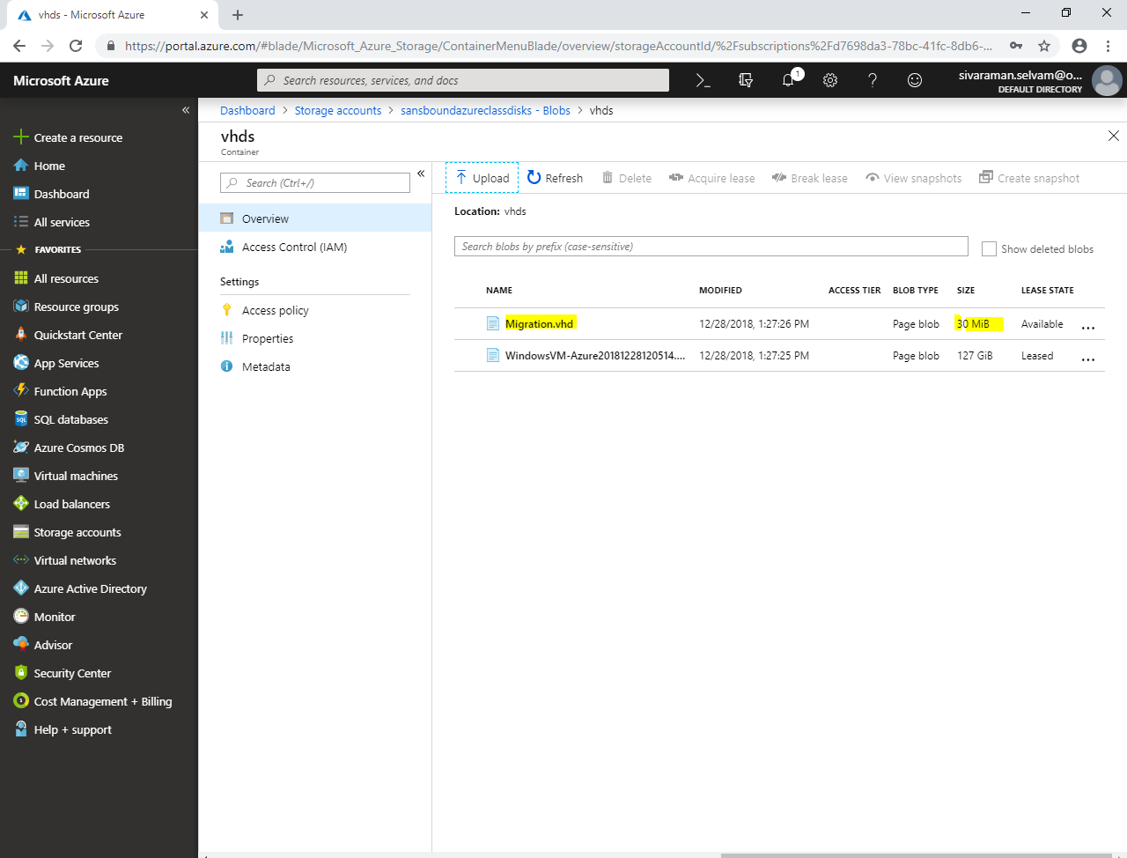

Click **“Virtual machines”** in left side panel.

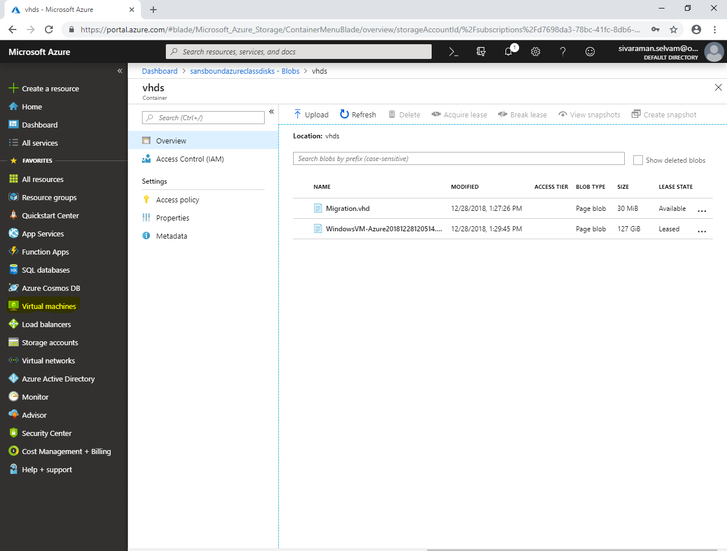

In **“Virtual machines”**,

Click **“WindowsVM-Azure”**.

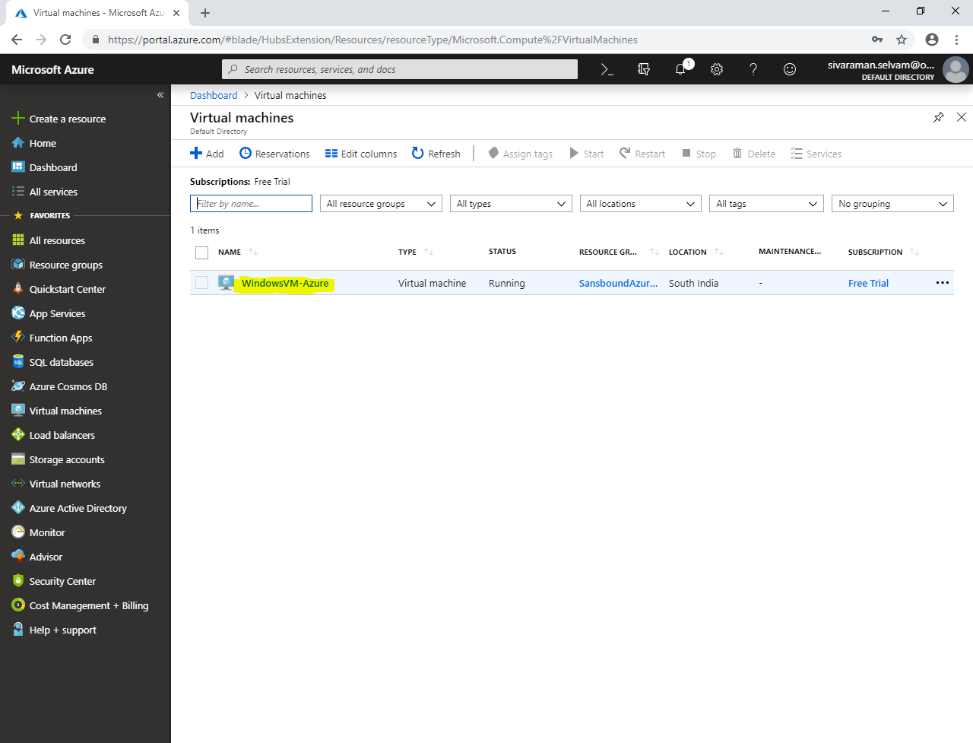

Now we have required to attach the blob storage in existing virtual machine.

In **“WindowsVM-Azure”**.

Click **“Disks”**.

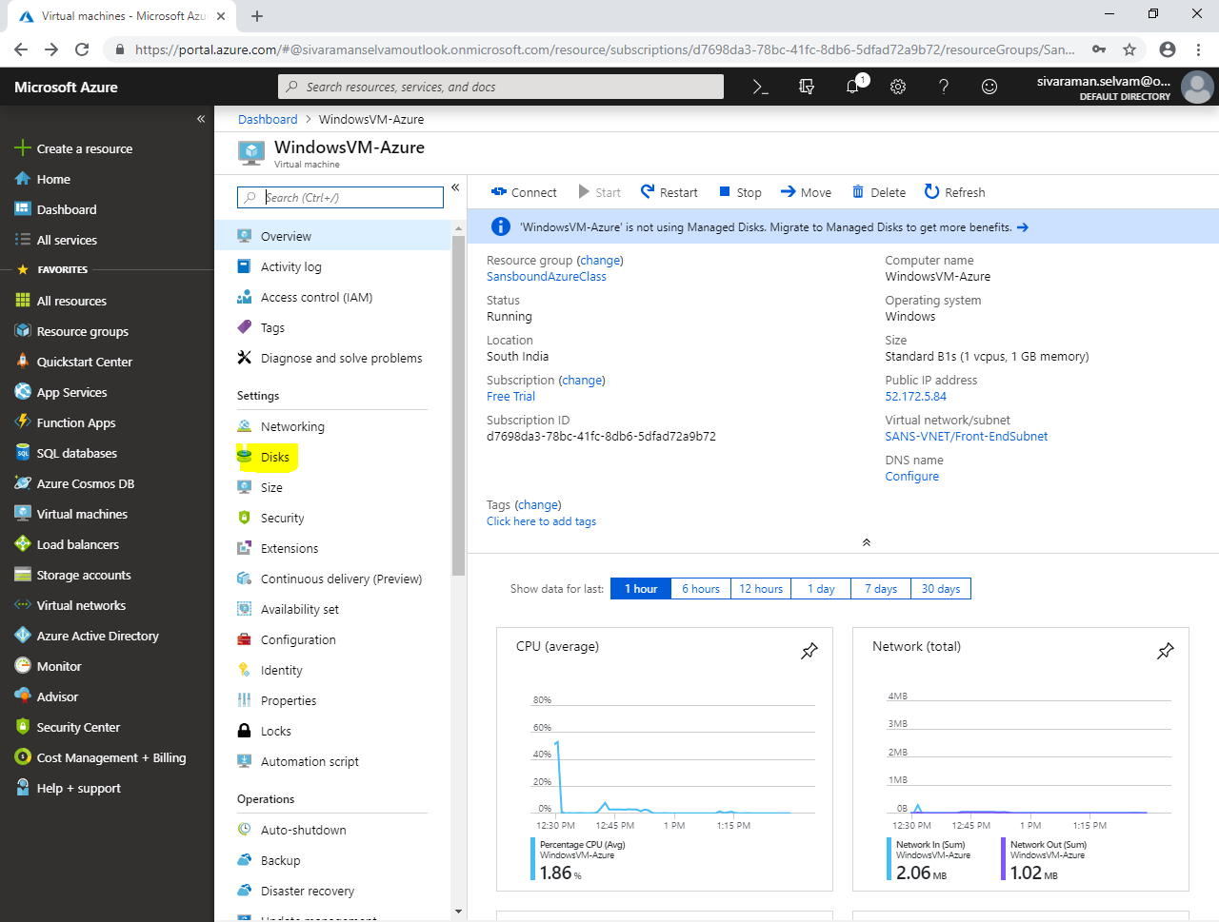

In **“WindowsVM-Azure – Disks”**.

Click **“Add data disk”**.

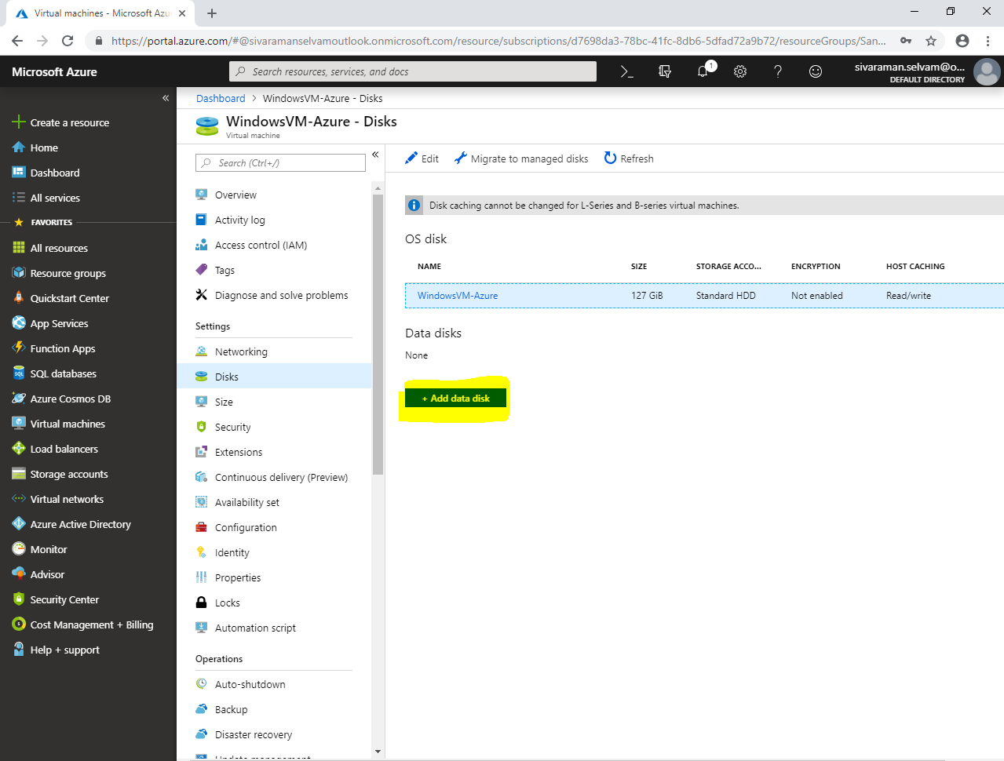

In **“Attach unmanaged disk”**

Type disk **“Name”** as **“Migration”**.

Select **“Source Type”** as **“Existing blob”**.

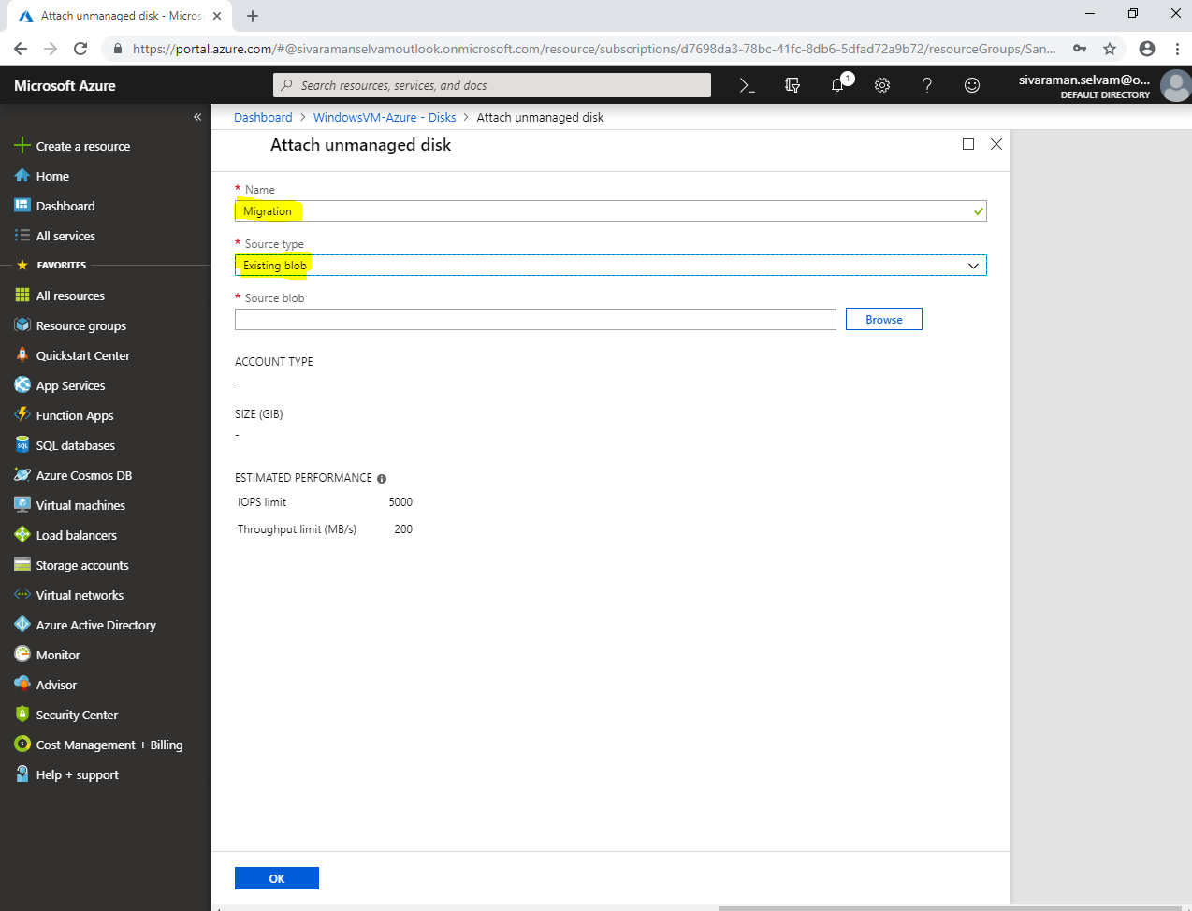

Click **“Browse”**.

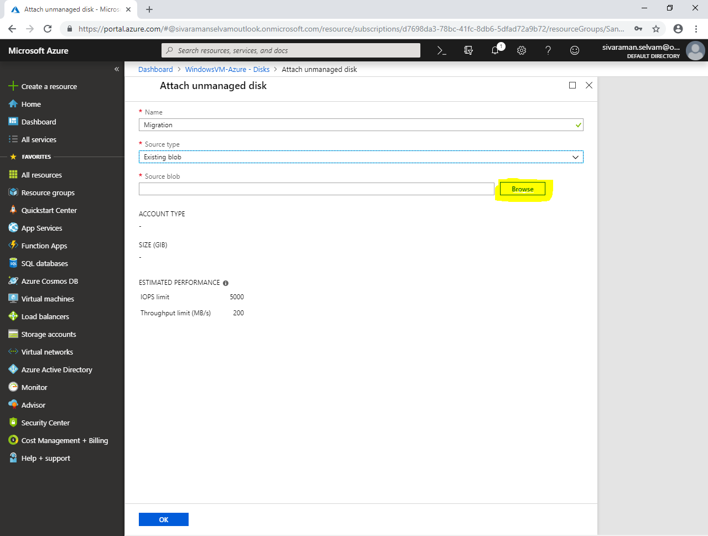

Click the **“Storage accounts”** which you are going to use.

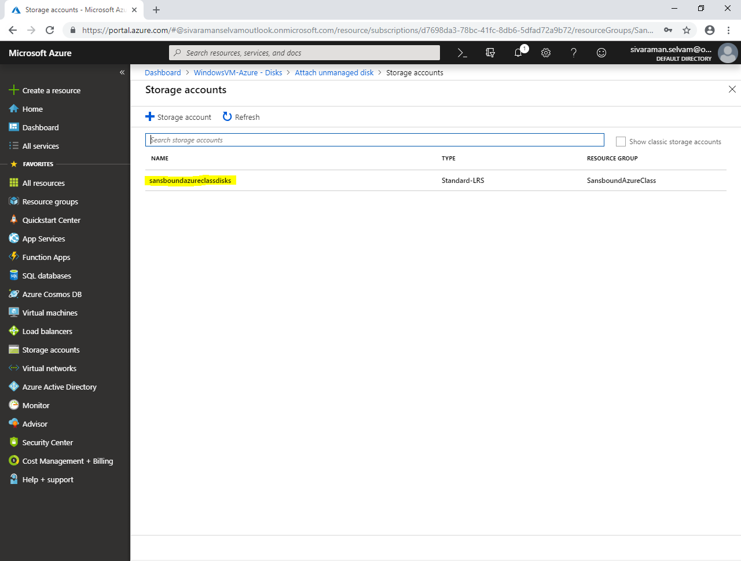

Click **“vhds”**.

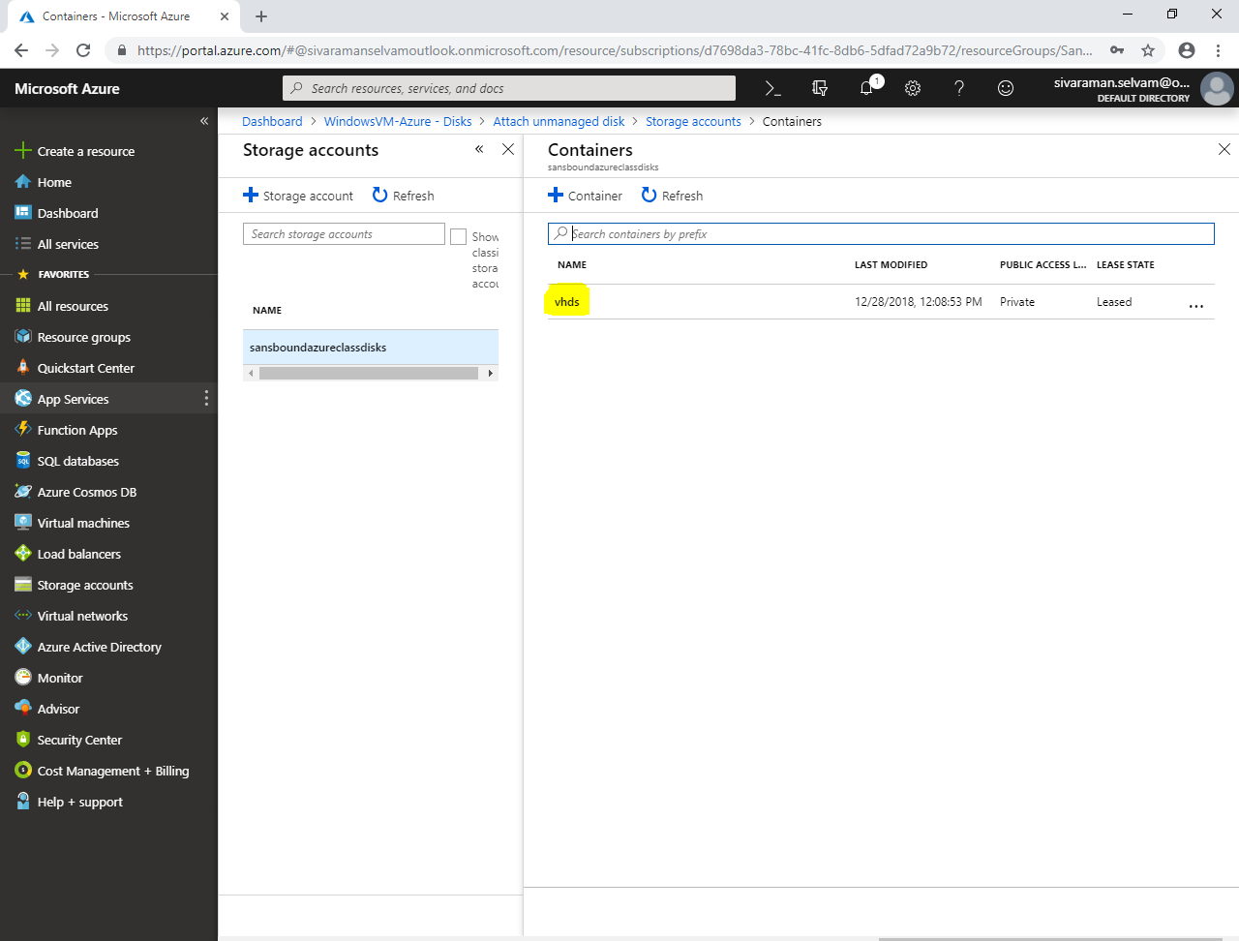

Select **“Migration.vhd”** and click **“Select”**.

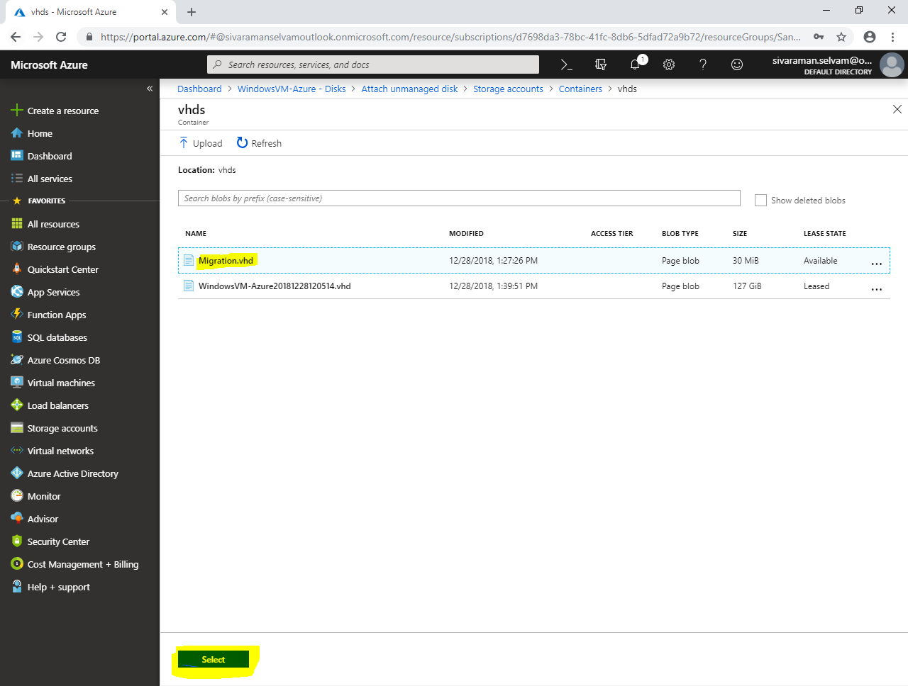

Click **“Ok”**.

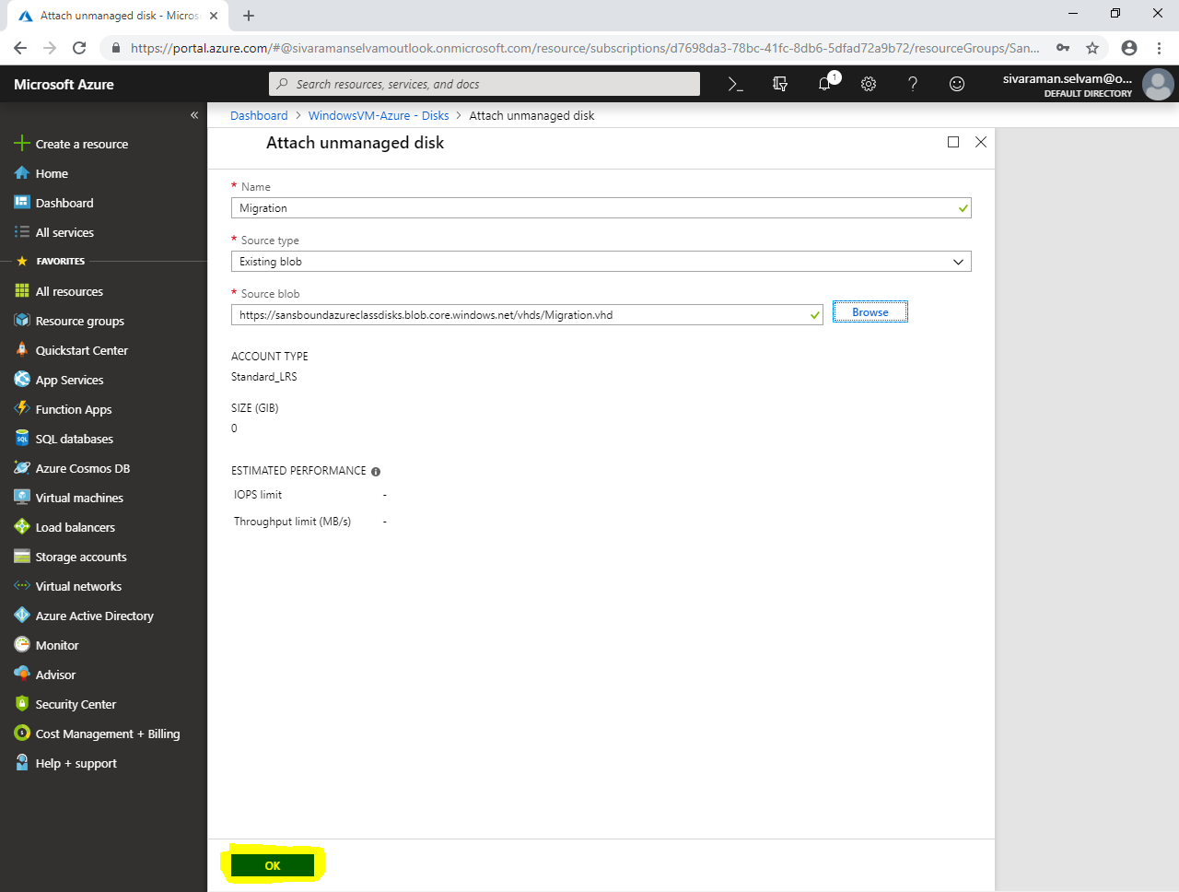

Click **“Save”**.

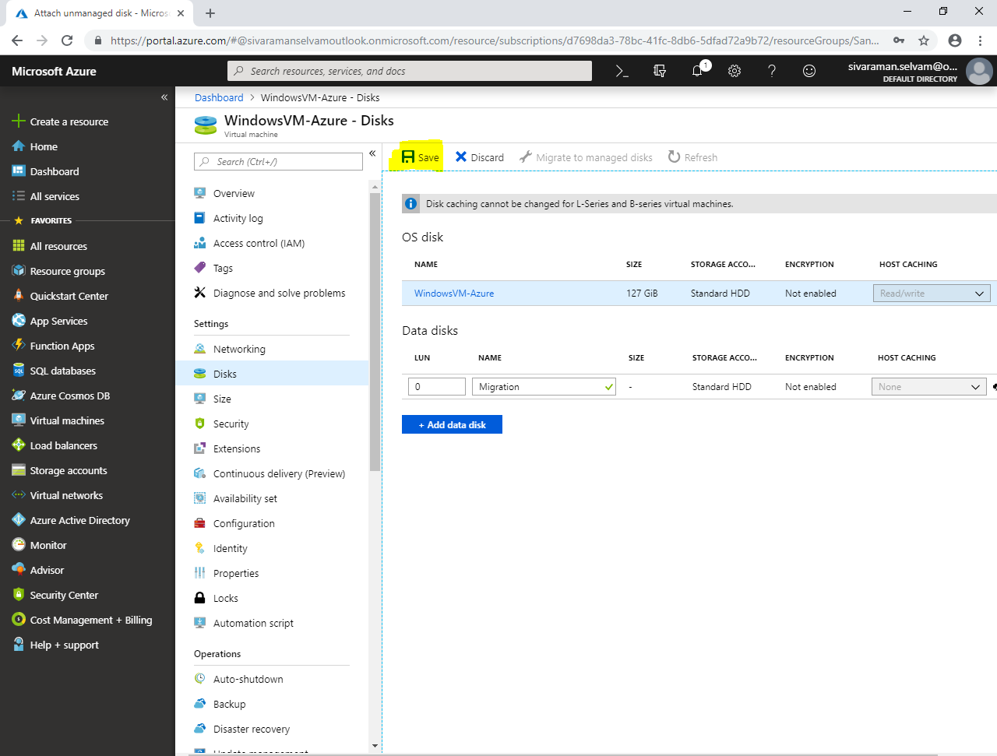

In **“Disks”,**

You are able to see OS disk and Data disks.

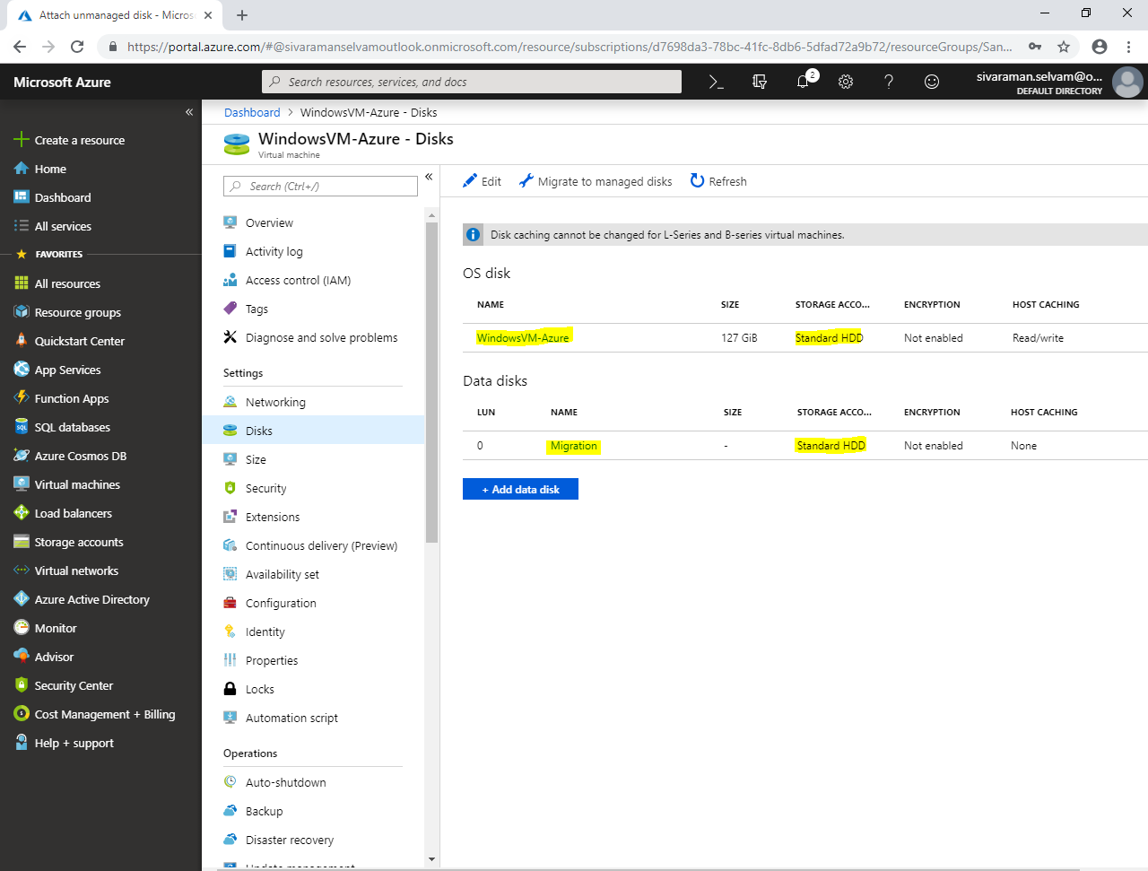

Click **“Networking”.**

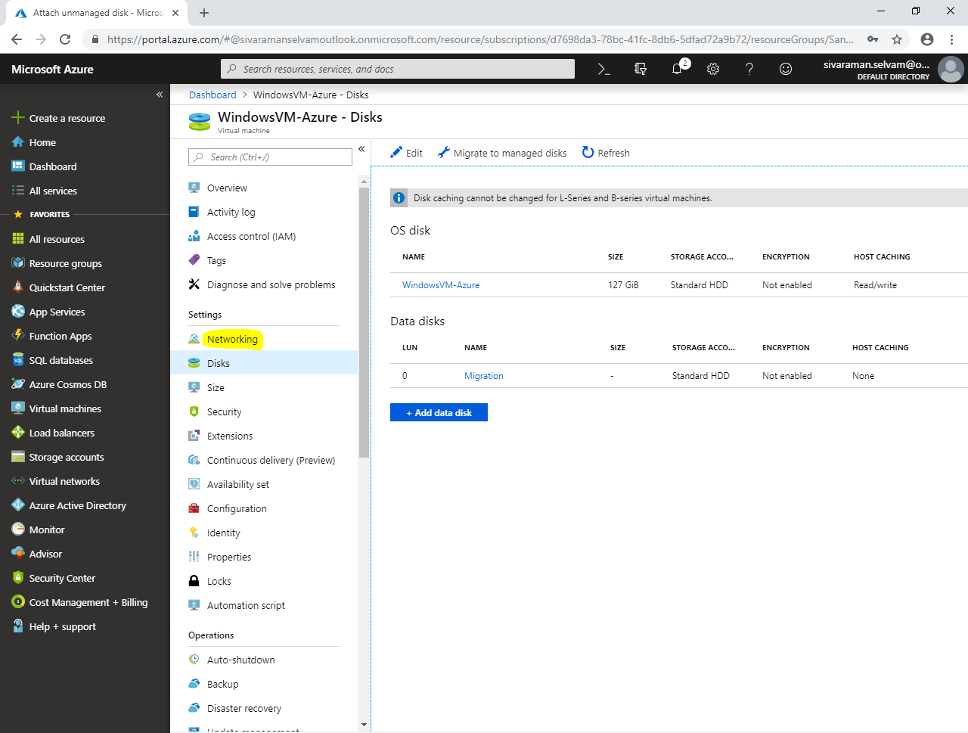

In **“Networking”**.

Kindly note the Public IP address to connect windows Server 2008 R2 through RDP.

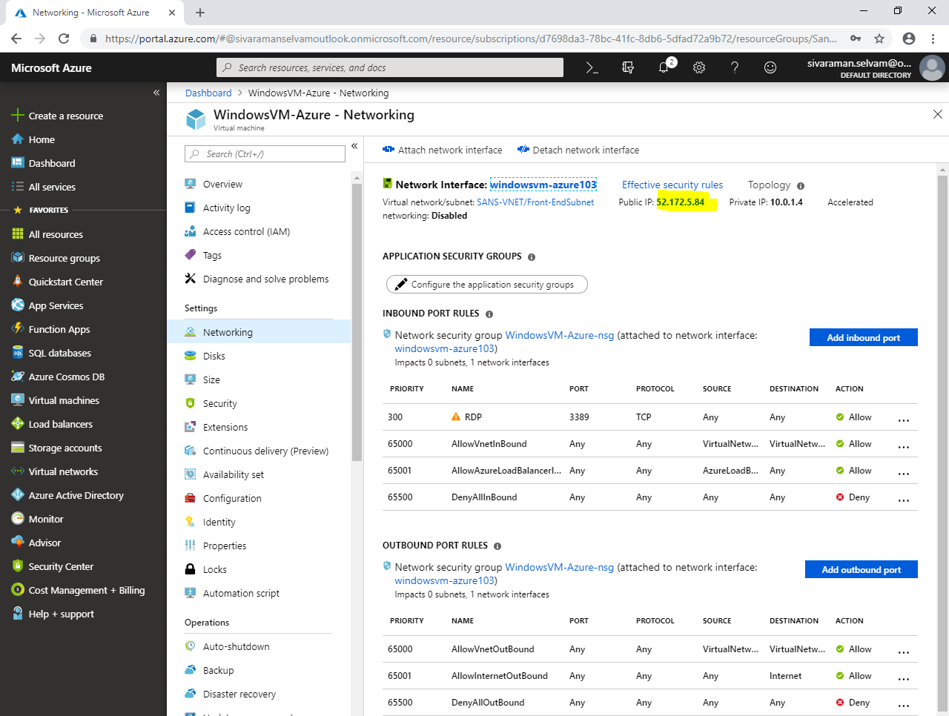

In your local machine,

Type **“mstsc”** in **“Run”** box and press **“Enter”**.

Type Public IP address of the windows server.

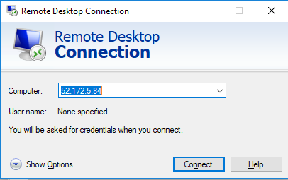

Click **“Connect”**.

Type **“username”** as sansbound

Type **“Password”** of Windows server 2008 R2.

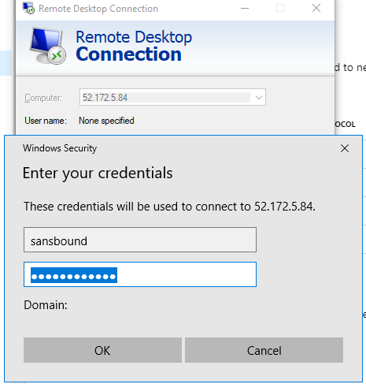

Click **“Ok”**.

Click **“Yes”**.

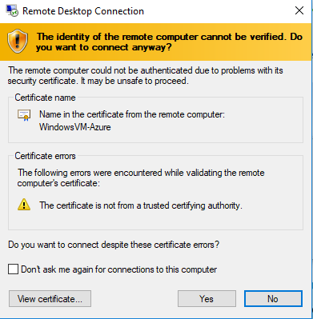

You have successfully logged on to Windows Server 2008 R2.

Type **“diskmgmt.msc”** in Run box and press **“Enter”**.

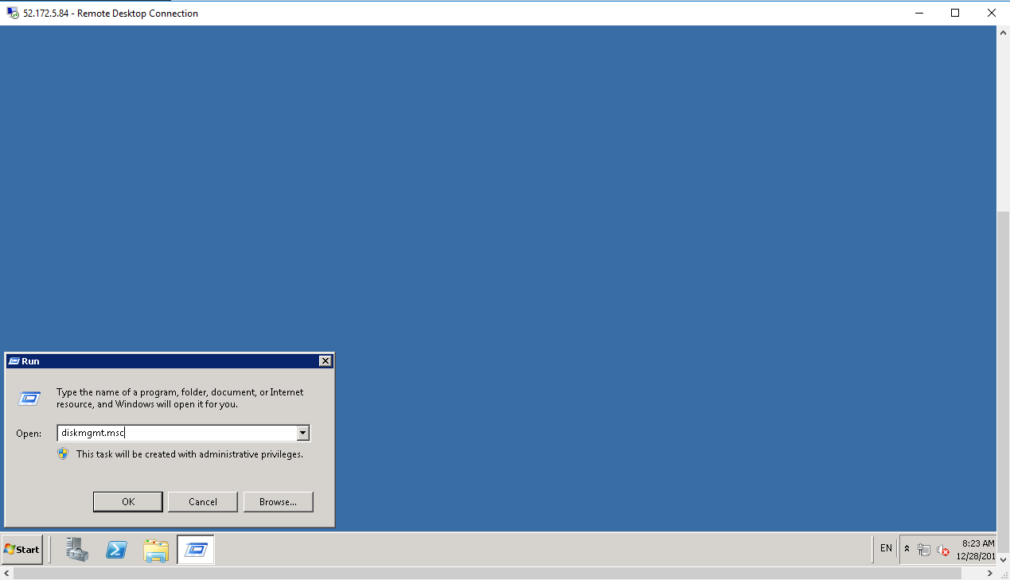

In **“Disk management”** you are able to see that vhd file which you have uploaded in Blob has been attached to this virtual machine successfully in “F” drive.

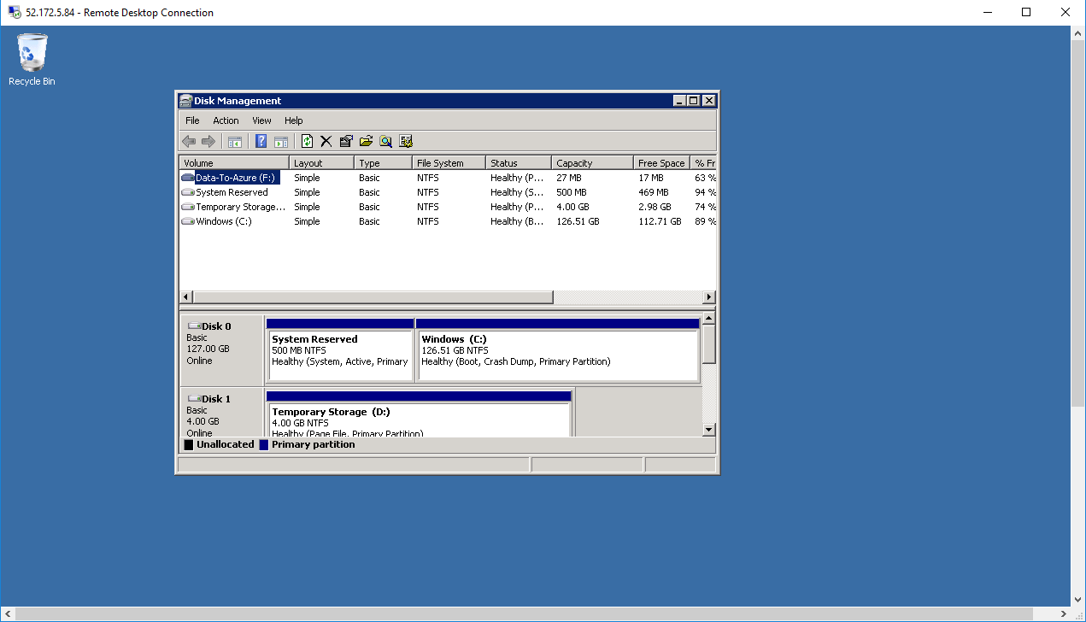

Open **“F”** drive in explorer.

Open the text file / document which you have uploaded from On premises / local machine.

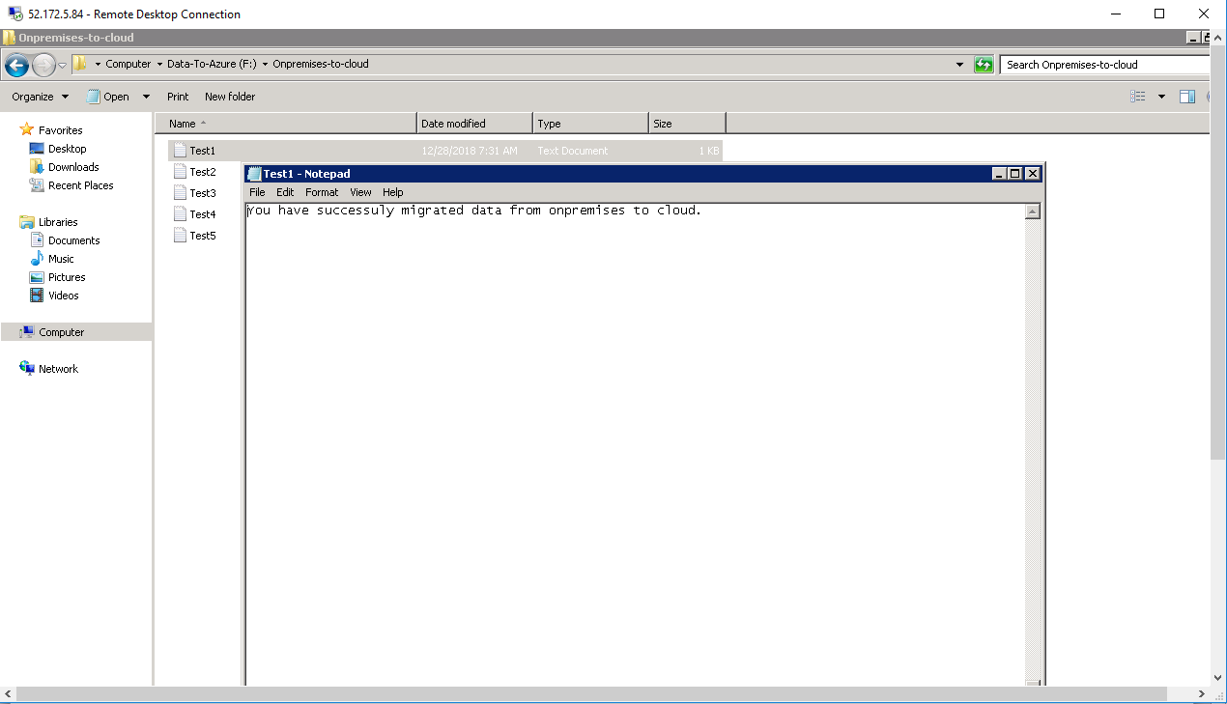

**If you have required to attach the Migration.vhd in another machine, you must required to detach from the existing virtual machine.**

In **“WindowsVM-Azure – Disks”**.

Click on **“Data disk”** named **“Migration”.**

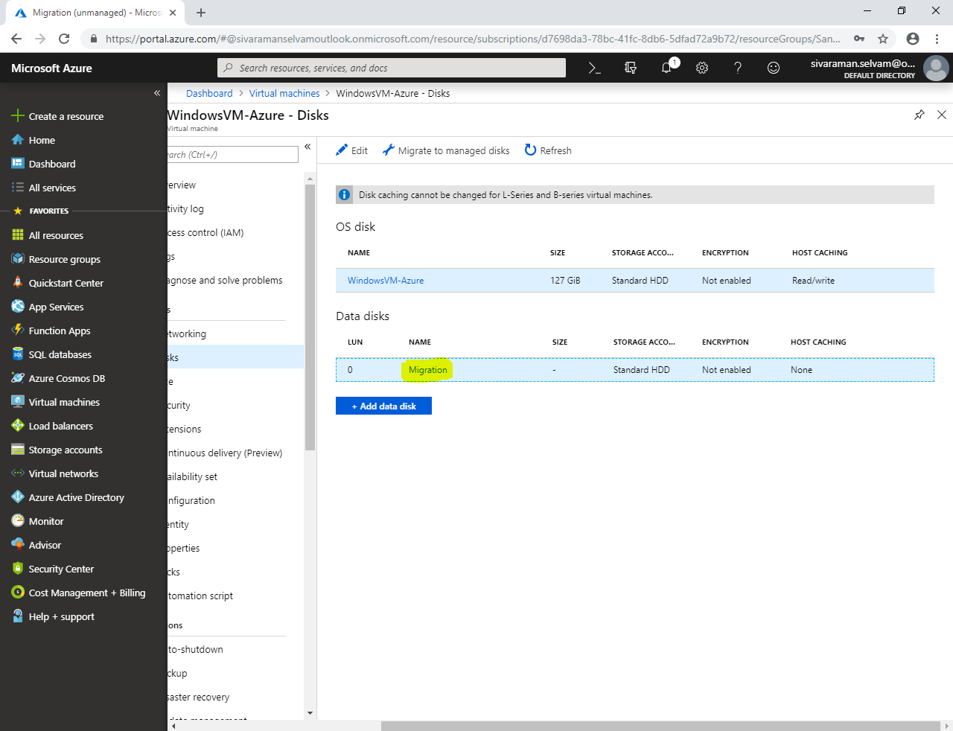

Click **“Edit”**.

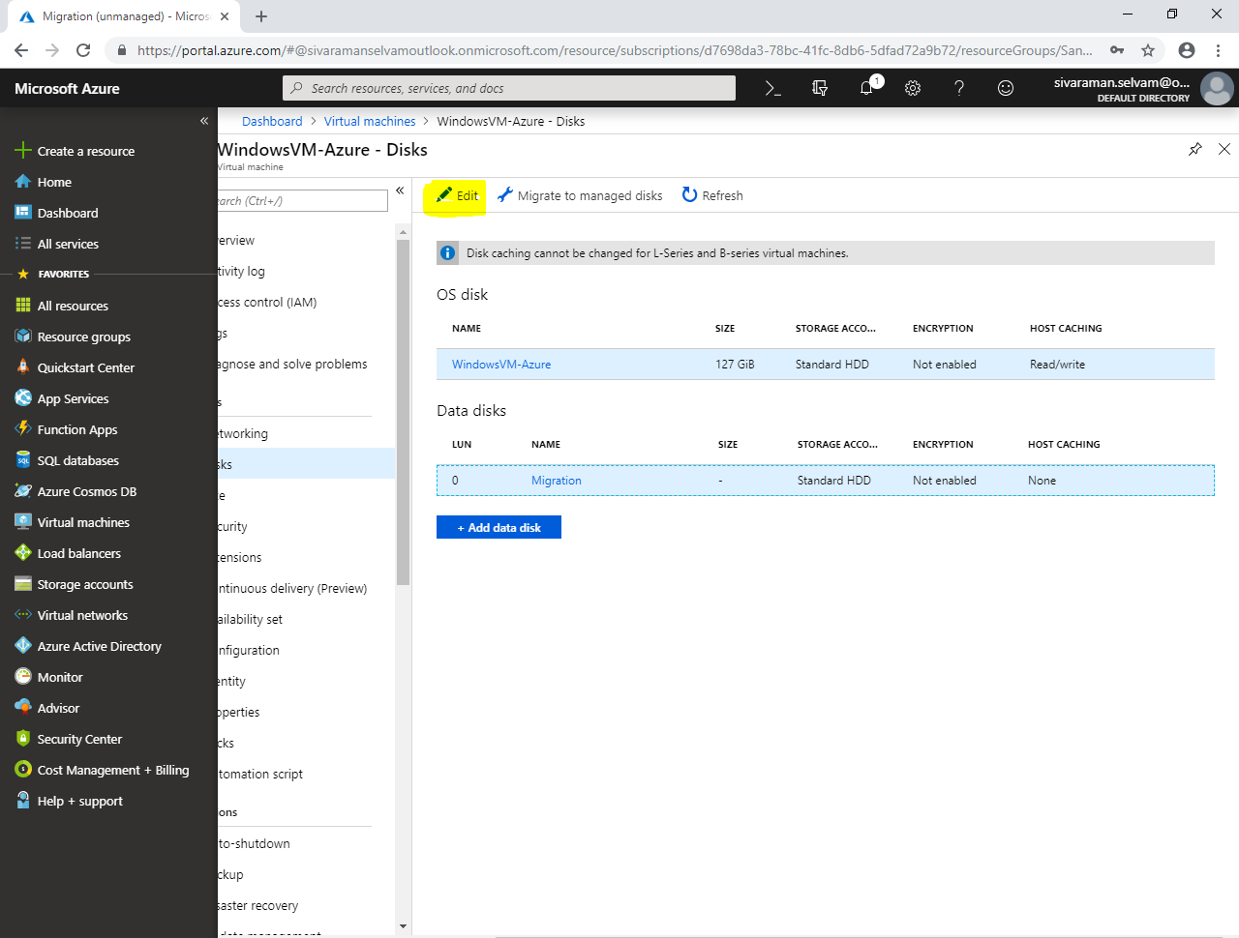

In **“Data disks”**

You are able to see new option, that is **“Detach”**.

Click the highlighted icon to **“Detach”** the migration.vhd from this virtual machine.

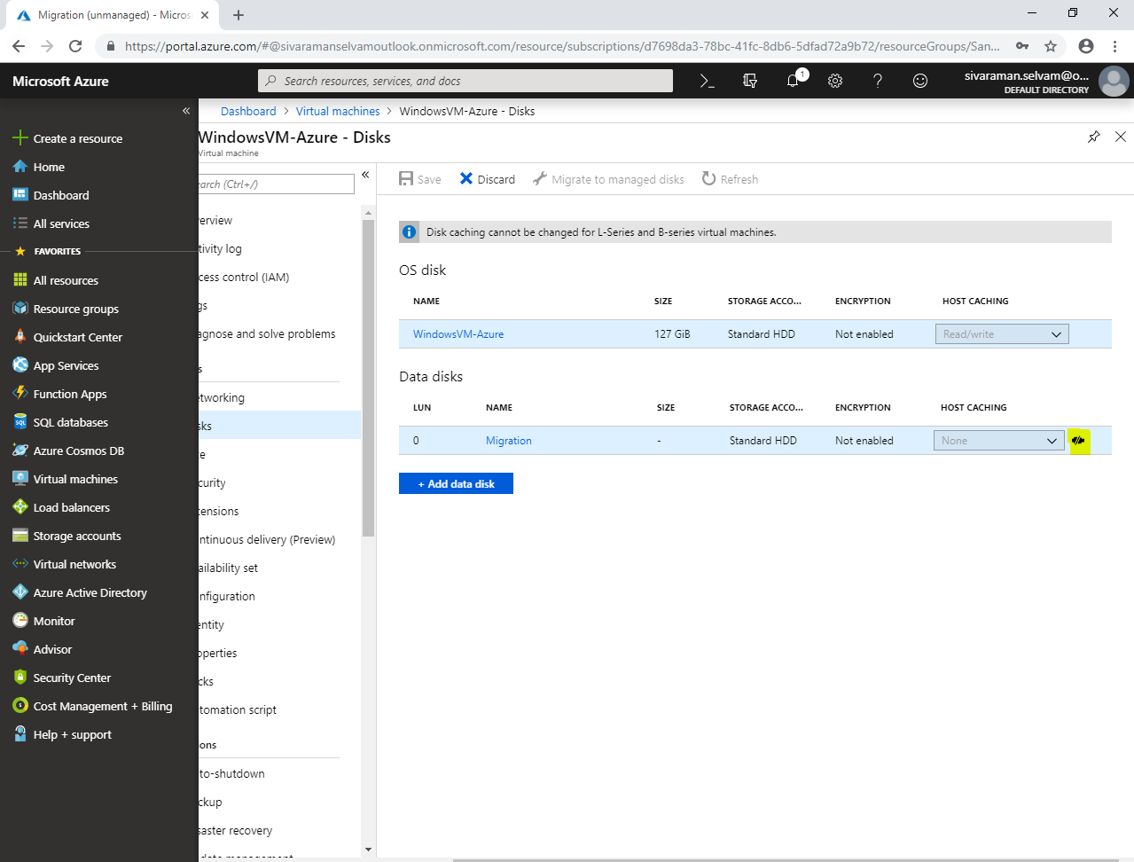

Click “Save” to apply the changes.

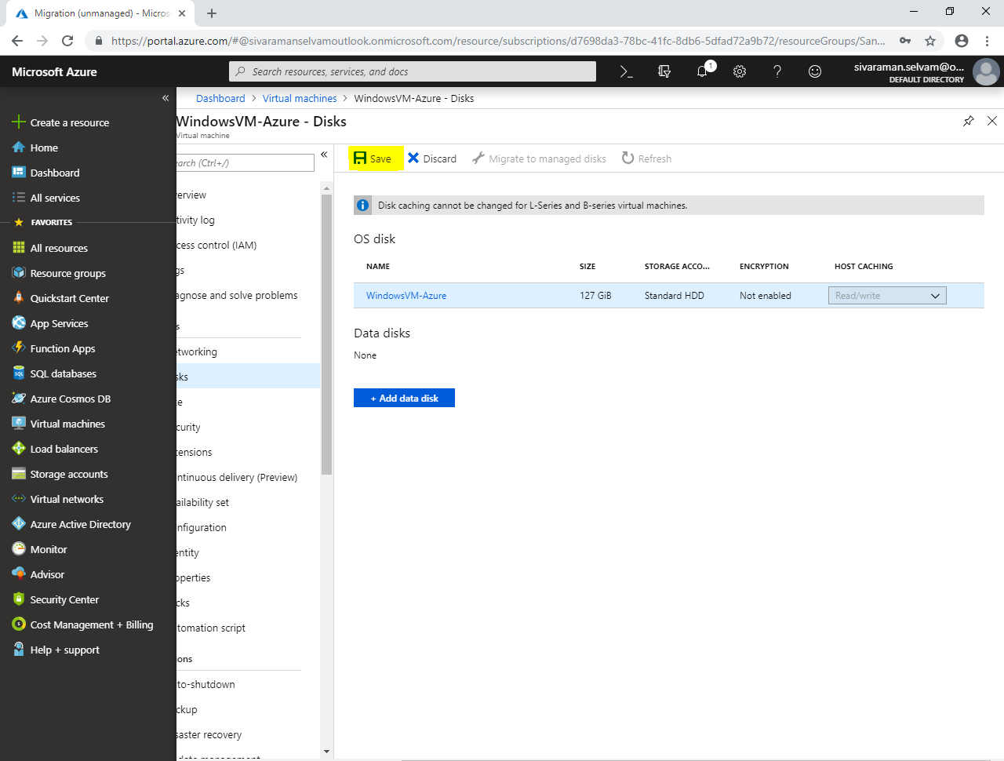

You have successfully detached migration.vhd from WindowsVM-Azure.

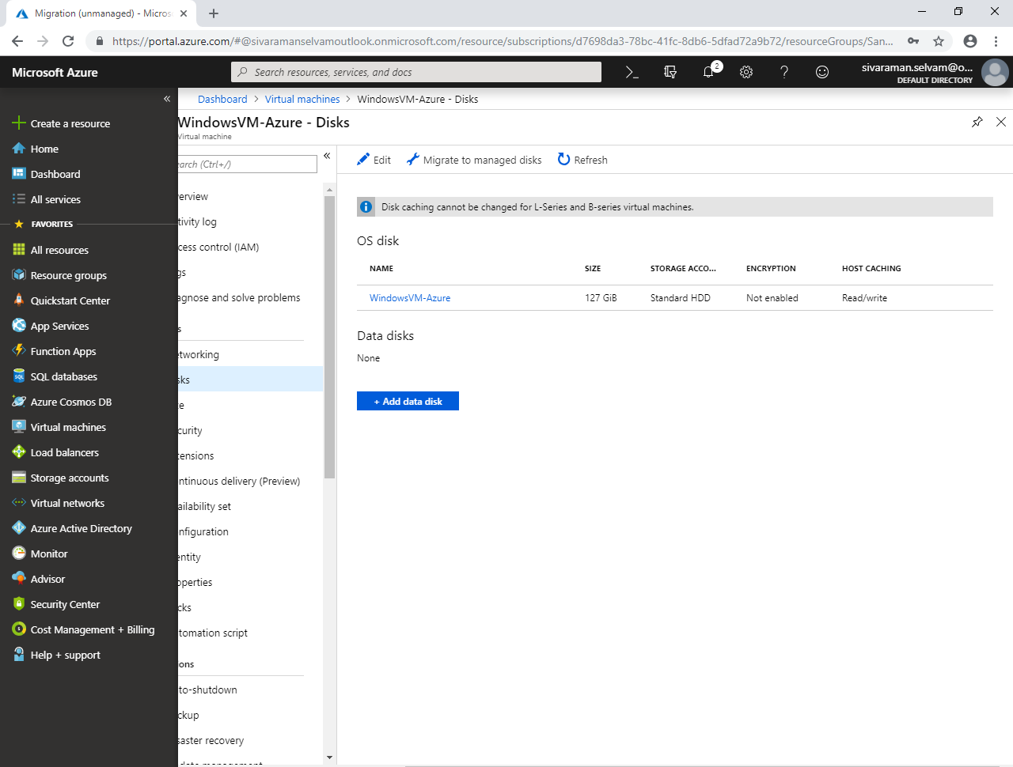

Note: If you have required to attach migrate.vhd to another virtual machine, you can create the virtual machine and attach it.